At homebGeigieZen User Manual

1 - Introduction

Now that you have a working bGeigieZen, you can start making measurements and contribute to the Safecast database, or simply use it as a hand held Geiger counter.

1.0 - Switch on the Zen
Your bGeigieZen is powered on/off with the on/off button on the right side of the M5Stack controller. The V4.x board does not have a separate power switch. Power on with a ½ second press of the button. Power off with a 4-second press of the same button.

Older V3.x.x boards will power up by first switching the power switch to the ON position then following the instructions relevant to your version of the Zen.
- If you happen to have a Zen with a M5stackCore2 V1.1 or a M5stackCore Black or Fire, or a M5StackCoreS3 you must press the power button on the M5Stack after turning on the Zen with the power switch.
- If you have a M5stackCore2 AWS(orange) or M5Core2 V1.0, M5stackCore1 Grey, the Zen powers on directly and the screen lights up.
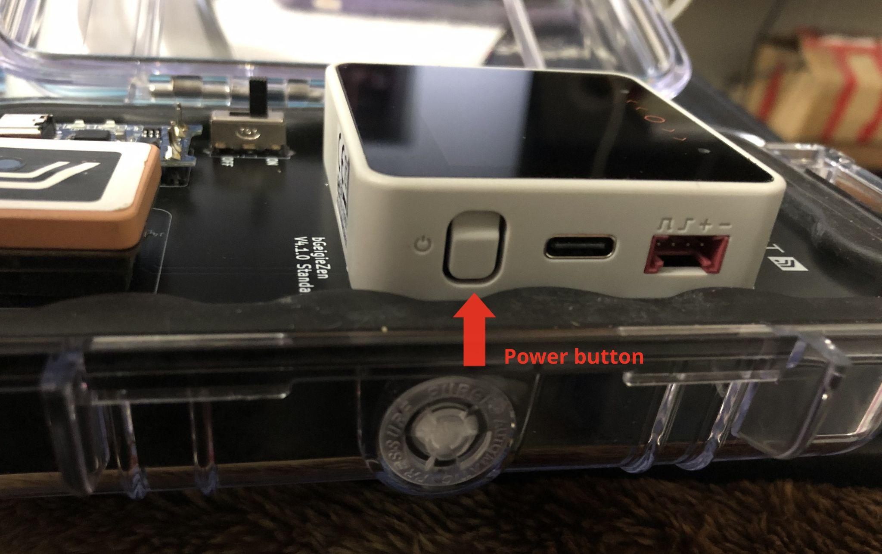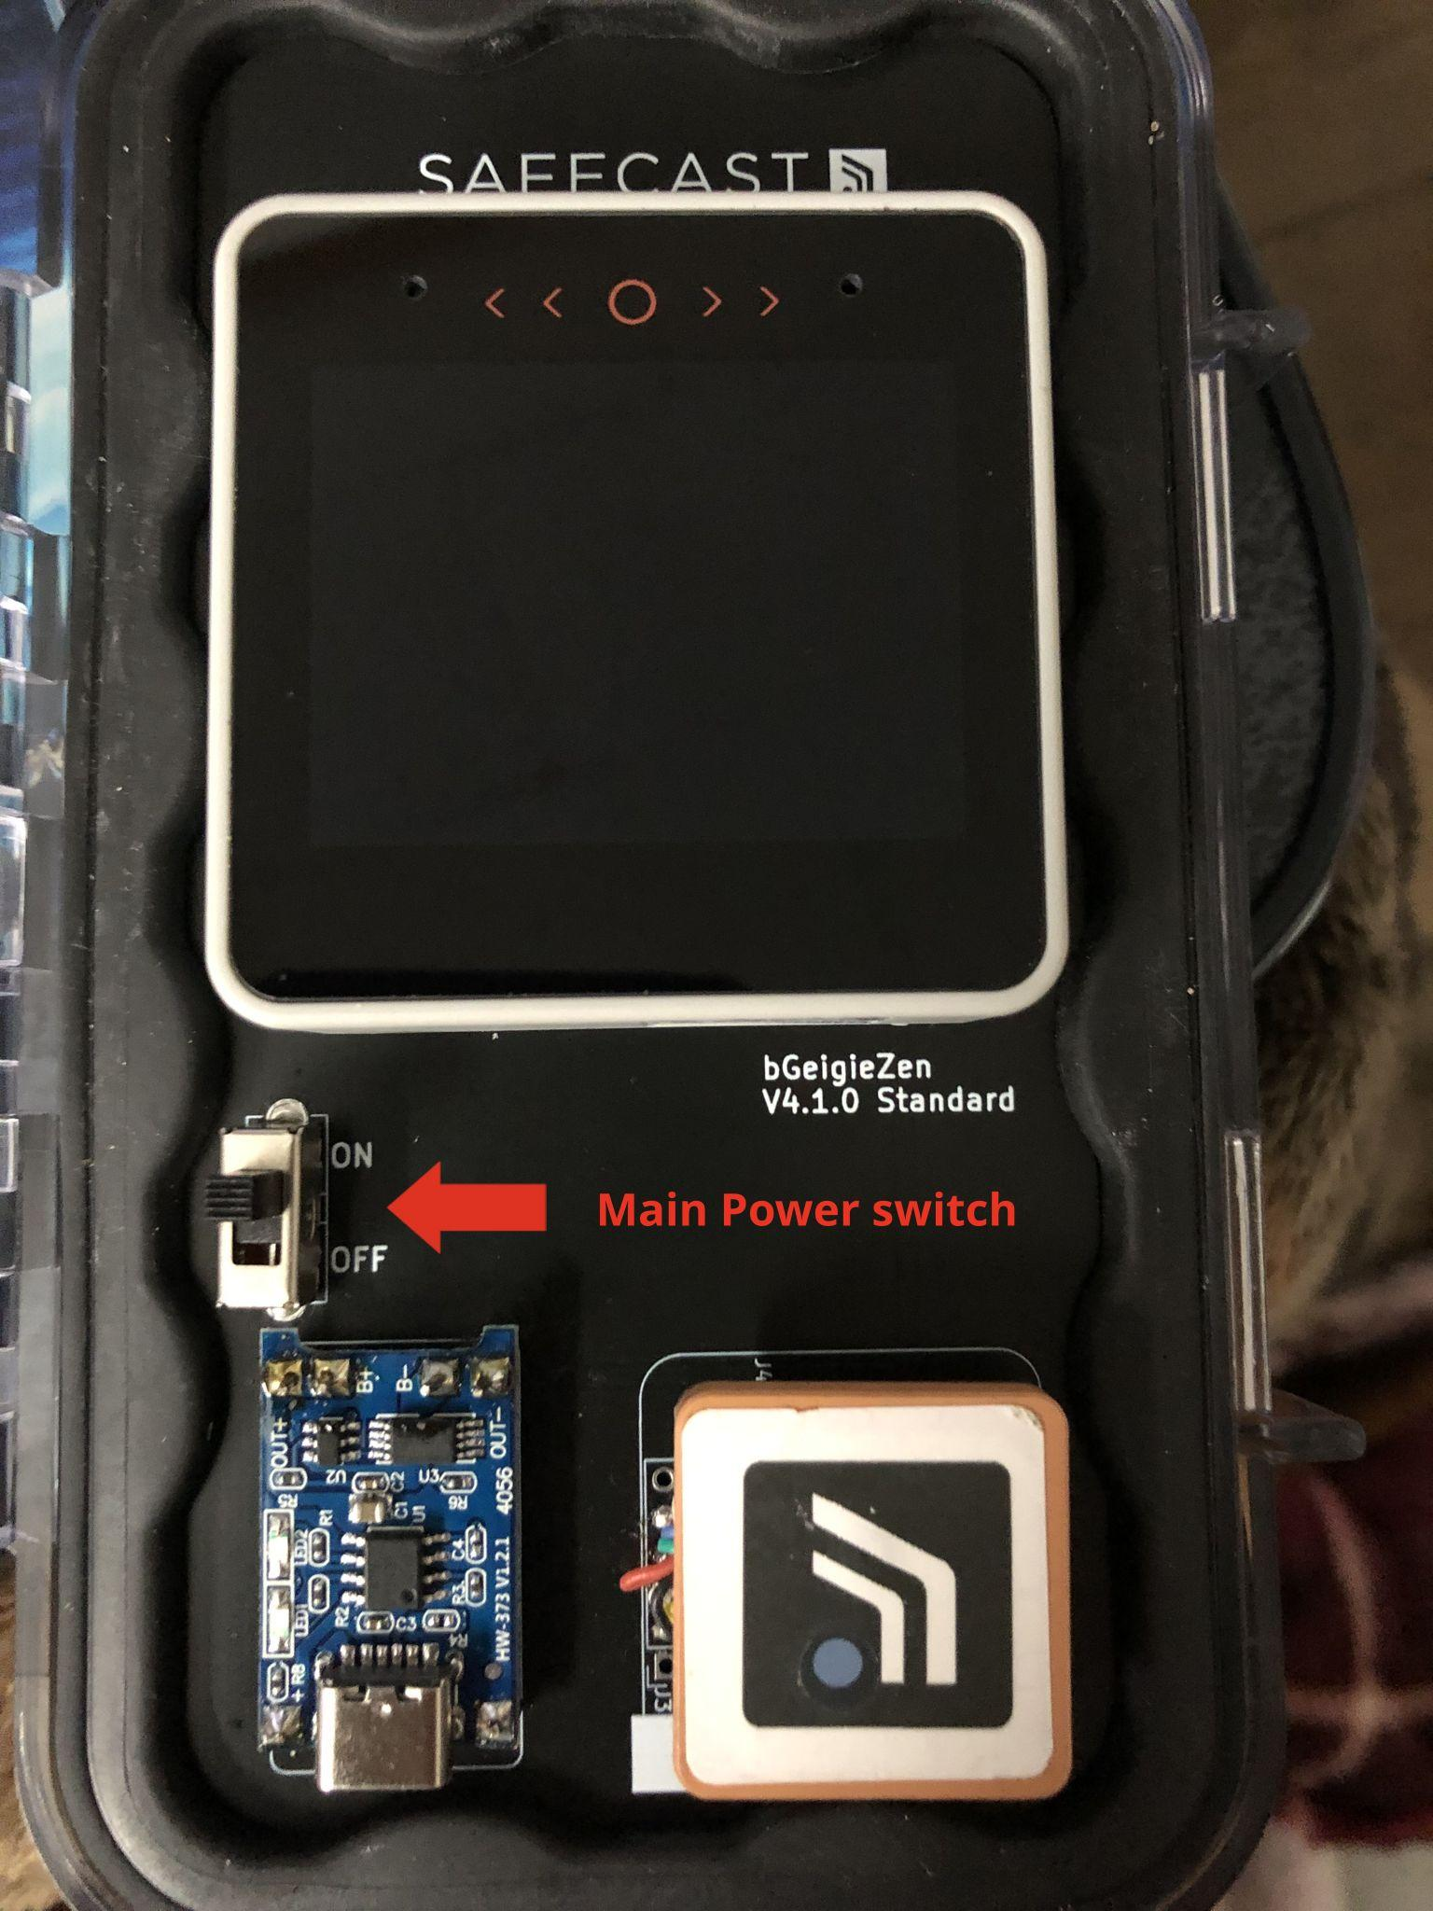

1.1 - Getting started
When your bGeigieZen starts up for the first time and finds a proper SAFEZEN.TXT file on the microSD card inserted in the controller, you will see the welcome message with the device ID.
- At the top, you will see two options:
- Continue (top right) - Start measuring, logging, or surveying.
- Learn more (top left)

When you press continue, you will enter Drive mode, where you can start logging measurements. On V3.3.1 and higher firmware, a clicking sound of the pulses on the detected radiation will be heard. Disable it with a long press on the Menu button.

Jump to 3 - bGeigieZen Basics.

For the impatient, jump directly to one of the modes of operation (you can navigate the menu with the small buttons(red dots or arrows on CoreS3) on the top of the display)
- 3.1 - Quick Start: Drive Mode Logging
- 3.2 - Quick Start: Survey Mode
- 3.3 - Quick Start: Real-Time Mode

1.2 - User interface notes

Status bar
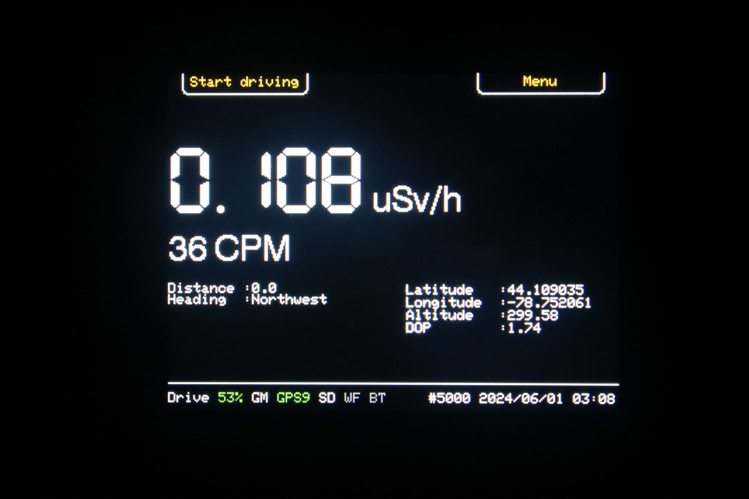
The status bar at the bottom of the Drive, Survey and Real-time mode screens shows:
- Drive Current mode (Drive, Survey and Real-time)
- NN% Battery percentage remaining
- GM for Geiger-Muller detector status. White means that your Zen is getting "counts", red means that there is no activity from the detector.
- GPSnn GPS status and number of navigation satellites used for a navigation fix. More satellites give a more precise position. The GPS receiver needs at least three satellites for a longitude-latitude position fix (2D) and four to add altitude.
The colour indicates the age of the latest position fix:
  - Green the fix was updated every second
  - Orange the fix is stale, and the last known position is shown in orange.
  - GPS? is shown while searching for satellites, before any are found.
- SD The microSD card is inserted and your Zen is using it.
- WF WiFi wireless networking. In Real-time mode, indicates that there is a connection to the local wireless network.
- BT Bluetooth connected.
- SN Is sound on/off (only on firmware 3.3.1 or higher).
- #5nnn The Zen ID number
- YYYY/MM/DD current date
- HH:MM UTC time, derived from the GPS receiver. If no GPS satellites are available, the time is taken from the built-in real time clock chip (if it has previously been set).

“Soft” buttons
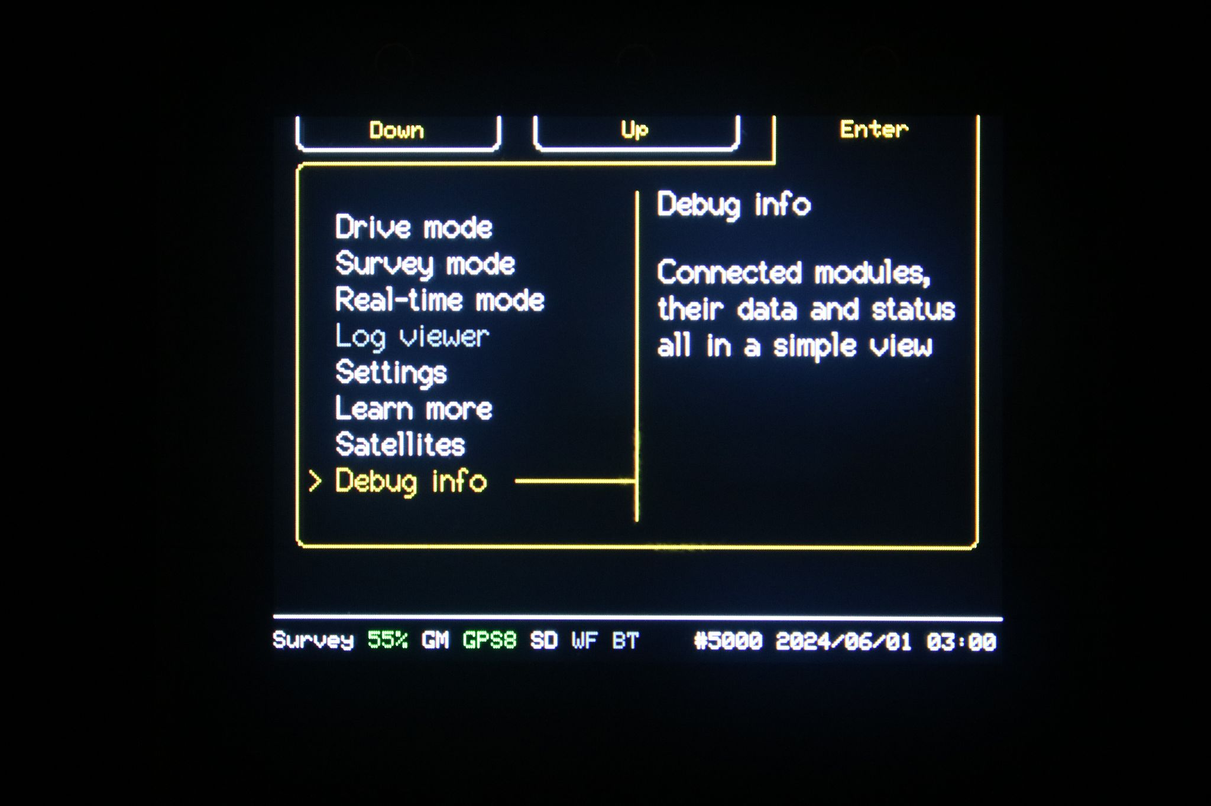
There are three buttons at the top of the screen, shown on the screen surface as small red/brown circles or arrows(they may be hard to see). Their functions depend on the current mode or screen being displayed. The legend appears at the top edge of the screen, but the touch-sensitive area extends beyond the top of the screen to include the little brown circle.

Screen blanking
The screen dims after a few moments of inactivity, then blanks after a longer delay. The dimming and blanking times are configurable. By default, the screen dims after one minute and blanks completely after 10 minutes. The TFT (LCD) screen suffers from “burn-in”. An area of the screen that constantly displays the same image or pattern will degrade in brightness and show a persistent ghost image. The brightness of the entire display will also degrade with use.

2 - Configuration
Your Zen needs to load its ID number and some operating parameters from the microSD card inserted in the card slot of the controller module, and supplied with the bGeigieZen. The essential configuration information is given in the file SAFEZEN.TXT on the microSD. The contents of the SAFEZEN.TXT file are given below in 2.4 - Contents of the SAFEZEN.TXT file.

2.1 - Startup configuration

When your bGeigieZen starts up, it attempts to load its configuration information from the microSD card. If there is no card in the slot, the Zen will show "SD card notification" on screen. You have the option to continue in minimal mode (top right menu button), or to load a card and reboot (top left menu button).

Minimal mode operation
In minimal mode, the Drive and Survey mode screens will display a warning highlighted in red "NO SD CARD INSERTED". If this is the first time powering up, the device ID is unknown and is displayed as “0000”. The device ID must be initialised from the microSD card before any logging can be done. You can still measure radiation and acquire time and position from the GPS module, but the measurements will not be logged.
.
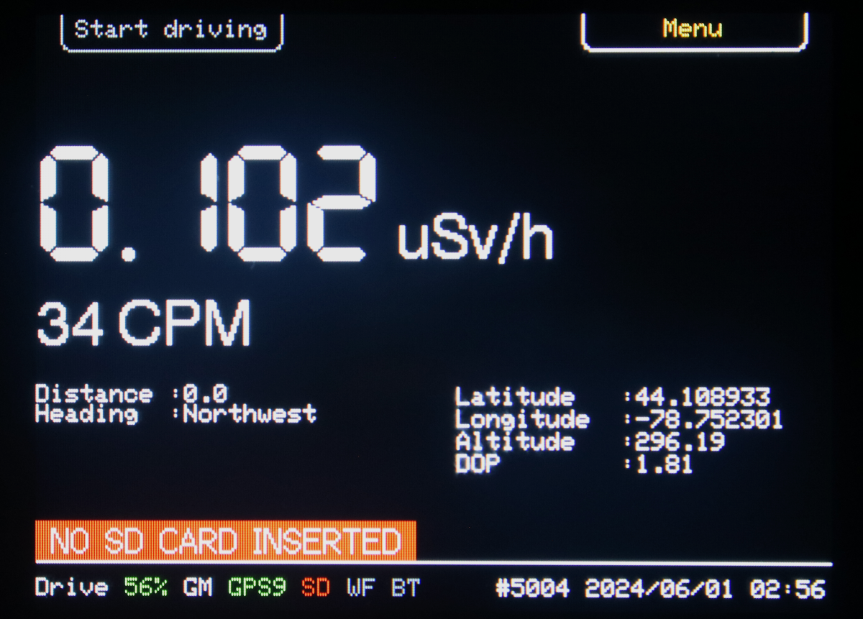

Real-time mode logging is still available in minimal mode without the microSD card as long as the device ID is stored in the controller’s non-volatile store (NVS). The "NO SD CARD
INSERTED" warning may be ignored.

2.2 - Preparing the microSD card
The microSD card must be formatted as a FAT32 file system. Most new microSD cards are already formatted, but you may need to prepare yours with your operating system's disk formatting utility. Typical cards are available as 512 MB to 32 GB. Formatting a volume larger than 16GB may give the controller trouble. In that case, you would need to partition the high capacity microSD card to restrict the size of the volume. Consult the documentation for the formatting utility.

For more details, see Appendix D

The file SAFEZEN.TXT is a plain text file and must be edited with a text editor. On Windows, use the standard Notepad app or try the free Notepad++ editor. On MacOS, use Textedit but make sure that you keep the file as a "plain text" document (see the top level menu Format > Make plain text). Do not use a document editor such as MS Word or Google Docs.

The SAFEZEN.TXT file can be updated by your bGeigieZen from the built-in Zen configuration web server, but there must be an initial version of the file that provides the device ID. The device ID cannot be written from the configuration server. See the separate configuration section 4 ‐ Configuration Web Server.

2.4 - Contents of the SAFEZEN.TXT file
The SAFEZEN.TXT file provides your bGeigieZen with its basic configuration. It can be edited on a desktop or laptop computer to provide the initial configuration, or it can be written from the Settings screens after configuring your Zen through the access point. For the web server configuration, see the separate configuration section 4 ‐ Configuration Web Server.

The only mandatory item is the device_id. Others are optional, and default values will be supplied by the Zen firmware. The default values are shown underlined in [ ] square brackets.
- user_name=safecast Name of the “owner” of the bGeigieZen.
- version=M.m.p [Default depends on firmware version] The version follows the "Major”, “Minor”, “Patch” convention, for example 3.2.3. In a Major revision, the device operation changes significantly over the previous major version. In a minor revision, there are minor changes to the way the device operates. In a patch, there are no visible changes, but some software defects have been corrected.
- device_id=5nnn [No default value] The device identification number. Safecast bGeigieZens are numbered 5001 to 5999. This number was assigned when your Zen kit (or completed unit) was sent to you. Please do not change the ID, it uniquely identifies your Zen in the Safecast database.
- api_key=20_CHARACTER_API_KEY [Empty value] Safecast API key to submit measurements directly over the network. Obtain yours from the Safecast API web pages.
- access_point_password=safecast [safecast] The password to log into the Zen configuration access point (leave as default).
- wifi_ssid=MY_WIFI_NETWORK [your wifi ssid] The WiFi wireless network to connect to the Internet. This is the same network name that your laptop or smartphone would use. Note: for mobile use, make this network the "hot spot" from your mobile phone.
- wifi_password=MY_SECRET [your wifi password] The password the Zen requires to connect to the Internet through WiFi. This is the same password that your laptop or smartphone would use on this network.
- wifi_ssid2=MY_SECOND_WIFI_NETWORK [empty] A second WiFi network name, for use when travelling (e.g. a mobile hot spot). Not required.
- wifi_password2=MY_SECOND_SECRET [empty] The password for the second WiFi network.
- wifi_profile=1 [1] Which WiFi profile is active: 1 for wifi_ssid/wifi_password, 2 for wifi_ssid2/wifi_password2.
- alarm_threshold=0 [100] The threshold of counts per minute (CPM) averaged over ?? Seconds at which an alarm would sound. See the Radiation Measurements page for details.
- screen_dim_timeout=60 The time in seconds before the screen starts to dim
- screen_off_timeout=0 The time in seconds before the screen saver starts. To disable, set the value to 0.
- animated_screensaver=1 if you want the screensaver to show a moving object, or simply completely blank the screen.
- fixed_latitude=±DD.dddddd [0] Latitude of location for Real-time mode operation from a fixed location, as degrees and up to 6 decimals, in the range ± 90 degrees. In the web server configuration menu, you have the option of using the last known location.
- fixed_longitude=±DDD.dddddd [0] Longitude of location for Real-time mode operation from a fixed location, as degrees and up to 6 decimals, in the range ± 180 degrees. In the web server configuration menu, you have the option of using the last known location.
- fixed_range=0.200000 [0.2] (kilometres) In Realtime mode operation, determines the upload rate from your bGeigieZen.
  - If your Zen’s location is within this range (in kilometres), the upload rate is once per minute if the CPM is below the alarm threshold, or once every 5 seconds if above.
  - Away from the fixed location, the upload rate is once every 5 seconds.

Updated version is at https://github.com/Safecast/bGeigieZen/tree/Battery-logging-working?tab=readme-ov-file#bgeigie-nano--safecasttxt

3 - bGeigieZen Basics
The bGeigieZen (or simply, Zen) starts up and displays a welcome message, then resumes the operating mode or screen that was active at shutdown. If this is the first start-up, the default is Drive mode and your Zen starts logging data directly to the microSD card.

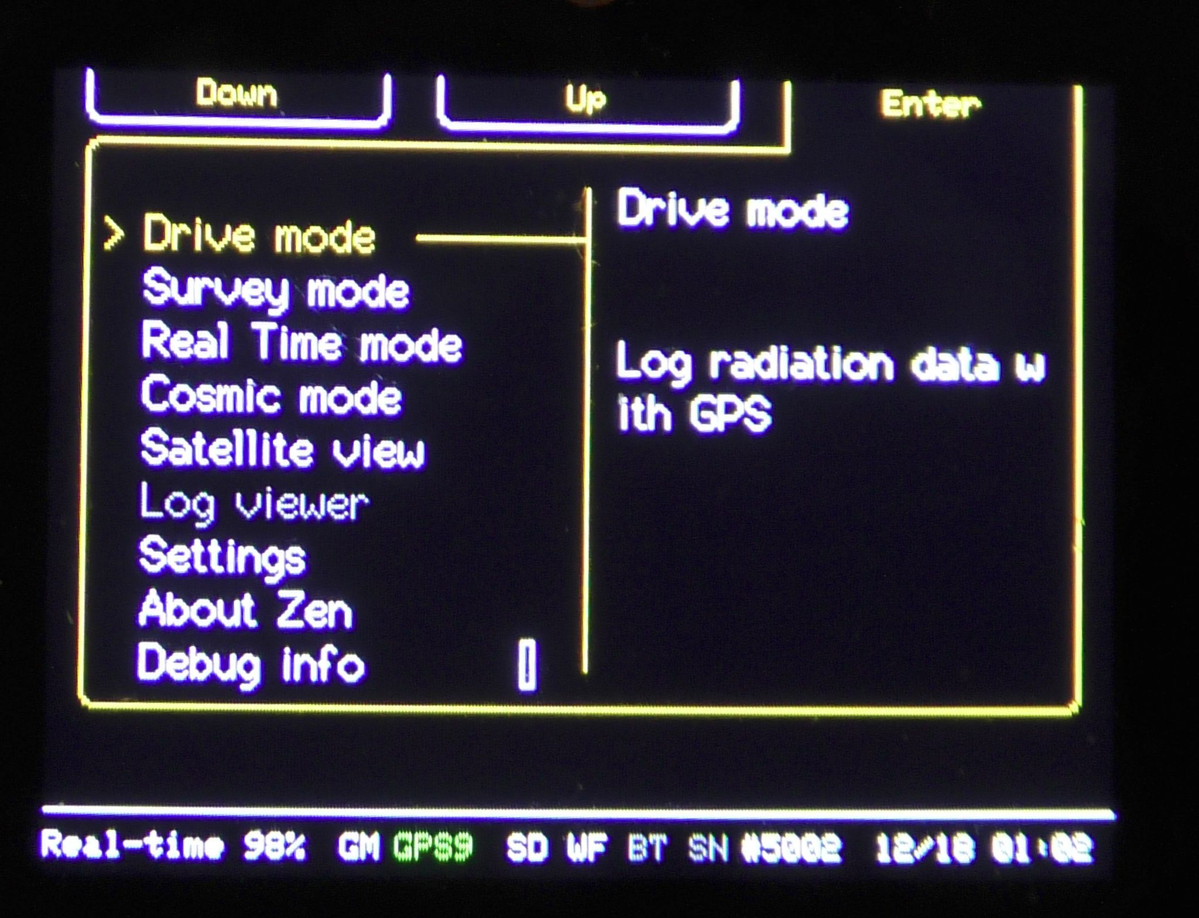

From the menu (top right button) you can select the following modes and screens, in order:
- Drive mode: Log timed and geocoded measurements in mobile operation (driving, walking, biking, etc.)
- Survey mode: Remove the device from the plastic case and make spot measurements at ground level.
- Real-Time mode: Log timed and geocoded measurements in real time directly to the Safecast database API over the Internet. In this mode, your Zen can log measurements either from a fixed location or mobile.
- Cosmic mode: This will disable Wi-Fi and Bluetooth, and put the GPS in a special high-altitude, fast-moving mode.
- Satellite view: A graphical view of the GNSS constellation in use (see 3.5).
- Log viewer: View and upload SD card log files over WiFi, without removing the microSD card.
- Settings: Configure Display, GPS, Sound, SD card, WiFi and Utilities (see section 4).
- USB File Transfer: Coming soon - currently disabled.

Other menu items allow you to alter the configuration or get additional information.

3.1 - Quick Start: Drive Mode Logging
The Drive mode display shows radiation measurements, location, date and time, and device status. Logging begins automatically as soon as a GPS position fix is calculated. You can configure your Zen to begin logging to a file immediately, in which case the position in the log file will be given as latitude, longitude 0,0. The display is updated every 1 second.

In Drive mode, your bGeigieZen logs to a file named according to the starting date and UTC time (24-hour) as "YYYY-MM-DD_HHMM.log". For example, "2024-02-18_1545.log" is a file started February 18, 2024 at 3:45 PM (UTC).

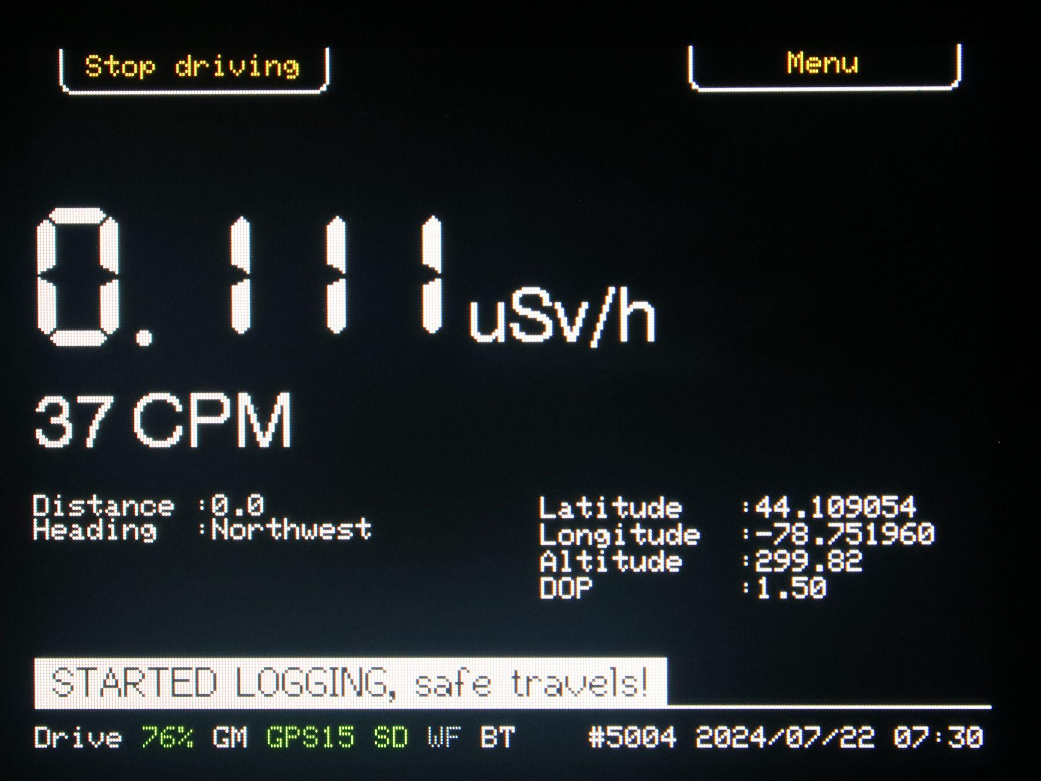

3.1.1 - Drive mode main display
- Current dose rate in microsieverts per hour (μSv/h), based on counts per minute for the most recent 60 second period.
- Counts per minute for the most recent 60 second period.
- Navigation
  - Distance travelled (meters) and approximate current heading as eight points of the compass, for example "Northwest".
  - Latitude and longitude in degrees and decimals to 6 digits, as ±DDD.dddddd. Positive numbers are east of the Prime Meridian, negative are west.
  - Altitude, meters above mean sea level.
  - Dilution of precision (DOP) is a figure of merit based on the geometry of the satellite positions. A lower number means that the satellites are widely dispersed overhead and the computed solution has less uncertainty. See the discussion in 6.4 - Dilution of precision (DOP).

3.2 - Quick Start: Survey Mode
In Survey mode, you can remove your bGeigieZen circuit board assembly from its case and take measurements at ground level, unobstructed by the case. This allows weaker particles (alpha, beta) to impinge the detector. (GET THE EXACT DETAILS?? ALSO, LOGGING??)

To enter Survey mode, press Menu (top right of screen) and navigate to Survey mode, then press Enter (top right). If your Zen was in Survey mode when you powered down, it will return here on power-up.

The Survey mode display shows the most recent radiation measurement, dose, location, date and time, and device status. Logging begins automatically, regardless of GPS status. The display does not dim or turn off – unlike Drive and Real-time modes, where the screen is dimmed to prevent TFT screen burn-in.

The dose measurement is based on a count in the last 5 seconds (CP5S), updated every 1 second. The dose measurement can be reset from Settings > Utilities > Reset dose.

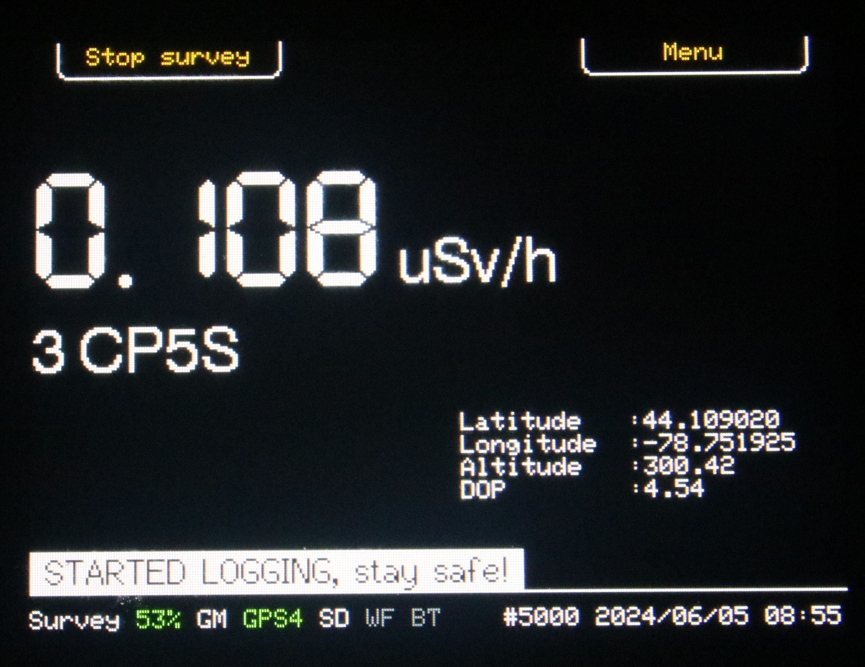

3.2.1 - Survey mode main display
- Current dose rate in microsieverts per hour (µSv/h), based on counts from the most recent 5 seconds.
- nnn CP5S Counts in the most recent 5 seconds.
- Position: white indicates that the position was updated in the last second, orange means that the GPS fix was lost and this is the last known position. Latitude and longitude are in degrees and decimals to 6 digits, as ±DDD.dddddd. Positive longitude is east of the Prime Meridian, negative is west. Positive latitude is north of the equator.
- Altitude, metres above mean sea level.
- Dilution of precision (DOP) is a figure of merit based on the geometry of the satellite positions. A lower number means that the satellites are widely dispersed overhead and the computed solution has less uncertainty. See the discussion in 6.4 - Dilution of precision (DOP).

3.3 - Quick Start: Real-Time Mode
In Real-time mode, bGeigieZen logs measurements directly to the Safecast measurements database. This makes logging easier by eliminating the tedious step of retrieving log files from the microSD card and submitting them manually to the API web page. See the settings page to set up your API key and network connection.

The Real-Time mode display shows radiation measurements, location, date and time, and device status. Logging begins automatically (??) as soon as a GPS position fix is calculated. You can configure your Zen to begin logging immediately, before obtaining a GPS fix, in which case the position in the measurement record will be given as latitude, longitude 0,0. (TO BE CONFIRMED??)

The QR code is a link to a real time display page of the measurements. The link is created dynamically based on the device ID and the current date and time.

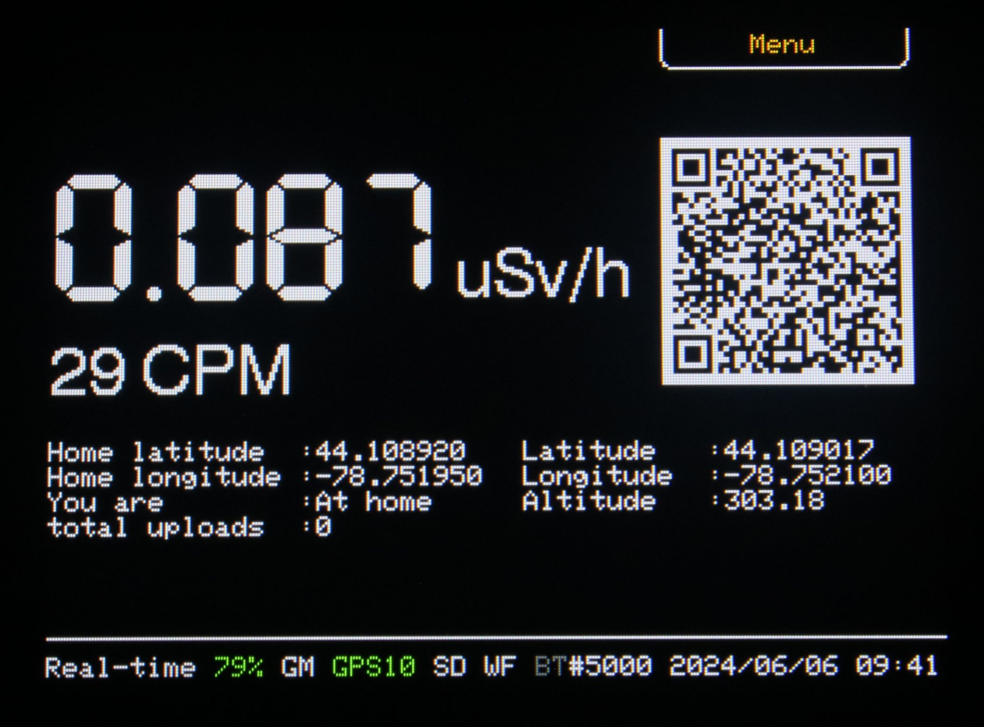

3.3.1 - Real-time mode main display:
- Current dose rate in microsievferts per hour (µSv/h), based on counts per minute.
- Counts per minute updated every 5 seconds.
- Navigation: there are two positions, the home position as entered through the configuration interface, the actual position reported by the GPS receiver and an indication that you are at or away from the fixed position.
  - Home latitude and longitude in degrees and decimals to 6 digits, as ±DDD.dddddd. Positive longitude numbers are east of the Prime Meridian, negative are west. Positive latitude is north of the Equator, negative is south.
  - Current latitude, longitude in degrees and decimals to 6 digits, as ±DD.dddddd, and altitude in metres. Positive longitude is east of the Prime Meridian, negative is west. Positive latitude is north of the Equator, negative is south.
  - You are: indicates where you are in relation to the configured fixed location. If the positions match to within the configured fixed range (default 500 metres) of the fixed location, it will display “At home”. When outside the fixed range, it will display “Roaming” in green. Lastly, if no GPS position is available, the message is “without GPS” in red.
- Total uploads The number of measurements reported to the database during this session. The number is reset when you switch mode or the unit is reset or powered off.

Real-time mode on-screen warnings
- CONFIGURED SSID NOT AVAILABLE The configured WiFi network connection is not available to connect to the Internet. You may use a fixed wireless LAN or a “hot spot” access point running on a smartphone. To retry, exit Real-time mode, check the Settings pages and return to Real-time mode.
- (OTHERS??)

3.3.2 - Real-time mode notes

WiFi only on 2.4GHz networks
Due to a limitation of the controller hardware, your Zen cannot connect to a local WiFi network if it does not offer 2.4GHz connections. Most access points offer both 2.4GHz and 5GHz.

“Fixed” mode in earlier firmware versions
In earlier versions of bGeigieZen firmware before v3.3.2 (??EXACT VERSION??), Real-time mode was named Fixed mode, and logging was enabled only when the position was within range of the configured fixed position. Logging was disabled when away from the fixed position.

3.4 - Quick Start: Cosmic Mode Logging
The Cosmic mode is for measurements made from an aircraft where the majority of radiation events are due to cosmic rays rather than background radiation from ground sources. In operation, the Cosmic mode is similar to the Drive mode. The display shows radiation measurements, location, date and time, and device status. Logging begins automatically as soon as a GPS position fix is calculated. You can configure your Zen to begin logging to a file immediately, in which case the position in the log file will be given as latitude, longitude 0,0. The display is updated every 1 second.

In Cosmic mode, your bGeigieZen logs to a file named according to the starting date and UTC time (24-hour) as "YYYY-MM-DD_HHMM.log". For example, "2024-02-18_1545.log" is a file started February 18, 2024 at 3:45 PM (UTC).

[[COSMIC MODE SCREENSHOT]]

3.4.1 - Cosmic mode main display
- Current dose rate in microsieverts per hour (μSv/h), based on counts per minute for the most recent 60 second period.
- Counts per minute for the most recent 60 second period.
- Navigation
  - Distance travelled (meters) and approximate current heading as eight points of the compass, for example "Northwest".
  - Latitude and longitude in degrees and decimals to 6 digits, as ±DDD.dddddd. Positive numbers are east of the Prime Meridian, negative are west.
  - Altitude, meters above mean sea level.
  - Dilution of precision (DOP) is a figure of merit based on the geometry of the satellite positions. A lower number means that the satellites are widely dispersed overhead and the computed solution has less uncertainty. See the discussion in 6.4 - Dilution of precision (DOP).

3.5 - Quick Start: Satellite view
This screen shows the constellation of navigation satellites used in computing a position fix and is used for troubleshooting problems with navigation. The receiver can read from a number of Global Navigation Satellite Systems (GNSS) constellations: GPS (USA), GLONASS (Russia), Galileo (EU) and Beidou (China). The options allow restarting the communication with the receiver or even initiating a cold restart.

4 ‐ Configuration Web Server
Your bGeigieZen has many operating modes and options configurable with the built-in Web server. From the Settings screen, you may launch the server on the local WiFi network or, if no network is available, on its own WiFi access point. Settings critical to measurements are saved in the SAFEZEN.TXT file, whereas non-critical usability settings are saved to the controller's non-volatile storage (NVS).

Note: the device ID may not be changed from the Web configuration server; it can only be configured within the SAFEZEN.TXT file.
The Settings menu has six submenus: Display, GPS, Sound, SD card, WiFi, and Utilities.
- Display: Dim brightness.
- GPS: Set Home GPS location.
- Sound: Audio settings (volume, click, alarm) and CPM alert level.
- SD card: Load from SD, Save to SD, Wipe SD card.
- WiFi: Start Access Point, Start on local.
- Utilities: Debug info, Factory reset, Reset dose, About this device.

4.1 - WiFi networking
Your Zen can join a local WiFi network or start its own access point.

4.1.1 - Set up the WiFi access point
This option is available at all times, even before setting the Internet access WiFi parameters.
- Press the Menu button
- Navigate to Settings and press Enter
- Navigate to WiFi and press Enter
- Navigate to Start Access Point and press Enter

Your Zen's built-in configuration server will appear in a new WiFi network as bgeigiezen-5xxx. Connect with the password shown on your Zen. 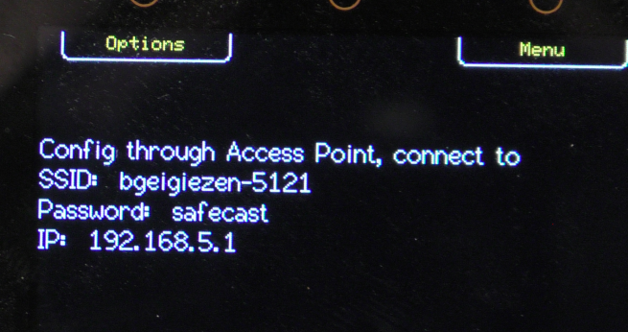
The parameters as shown on the controller screen. Connect from your computer or smartphone to the access point. Open your browser and got to 192.168.5.1. If your browser flags the pages as not secure, ignore the warning and connect anyway. This is a captive web server and there is no connection to the Internet. You should be greeted by a screen like this.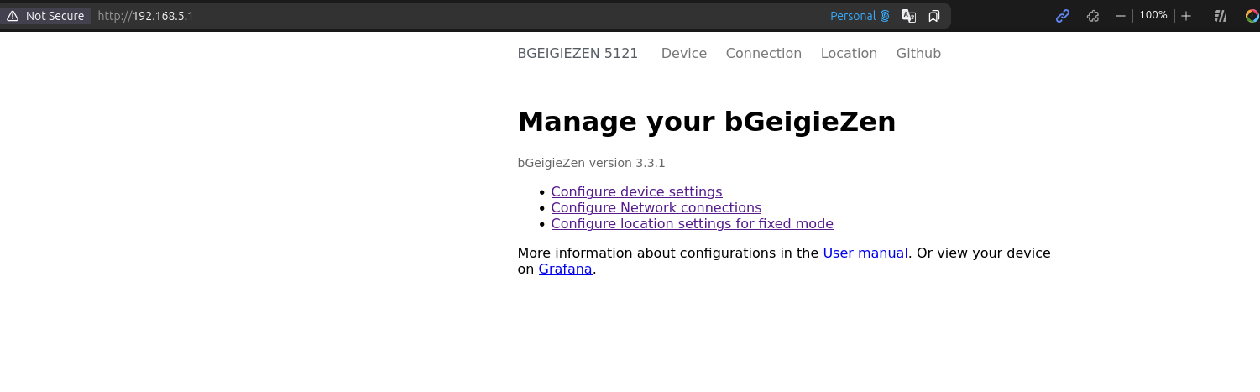

4.1.2 - Join an existing WiFi network
To use this method, you must first configure the parameters to join an existing WiFi network by editing the SAFEZEN.TXT file or through the access point (see above).
- Press the Menu button
- Navigate to Settings and press Enter
- Navigate to WiFi and press Enter
- Navigate to Start on local and press Enter

Your Zen's built-in configuration server will appear on the WiFi network. The connection parameters are as shown on the controller screen. Connect from your computer or smartphone. If your browser flags the pages are not secure, ignore the warning and connect anyway. This is a captive web server that will not forward anything to the Internet.

4.2 - Configuration server pages

4.2.1 - Device
- CPM Alert threshold: In Real-time mode, upload data more frequently when the counts per minute (CPM) value is above this threshold. Setting this to 0 (zero) will cause the bGeigieZen to upload at the high rate regardless of the count.
- Screen saver timing: the TFT display in the controller can suffer from image persistence (burn-in) wfuphen the same image is displayed for long periods. The screen saver dims the display, then blanks it. While blanked, you have the option of showing an animated screensaver message.
  - Screen dims after... (in seconds). Set to 0 to disable screen dimming.
  - Screen turns off after... (in seconds). Set to 0 to disable the screen turning off.
- Big radiation value on display: In Drive and Survey modes, the screen shows the radiation dose in microsieverts per hour (μSv/h) and the counts per unit time (per minute in Drive, per 5 seconds in Survey). This option determines which of the two is displayed in large characters.
- Logging options: When entering the Drive or Survey modes, this setting determines if the logging starts automatically, or if it must be started manually with the Start Logging button. Safecast recommends the automatic setting to avoid inadvertently missing measurements. It is safe to start logging before the first GPS fix because the database will only accept geolocated measurements, and refuse any with 0,0 coordinates or invalid time.
- Create journal logs: Optionally create and add to a journal log file. The journal is a separate file that will contain all measurement lines regardless of the current operating mode. The journal is meant for verifying correct device operation or troubleshooting measurement errors.
- Don't add invalid lines to log files: Optionally log all measurements even without time or position information, or no radiation counts. It is safe to start logging before the first GPS fix because the database will only accept geolocated measurements, and refuse any with 0,0 coordinates or invalid time.
Note: The default for the bGeigieNano is to wait until the GPS receiver provides time and location. In the bGeigieZen, this is a configurable option.

4.2.2 - Connection
Update the network connection parameters. This applies to the built-in access point, as well as the connection to an existing WiFi network. Real-time mode needs the WiFi network to log measurements directly via the Internet.
- bGeigieZen password: The password for the WiFi access point when starting the bGeigieZen configuration server. For simplicity, keep the default "safecast". The network name of your bGeigie Zen access point is based on its ID number: bgeigiezen-5nnn .
- WiFi network name: your local WiFi network name. This is the network that your Zen would use to log measurements via the Internet.
- WiFi password: the password to connect to the WiFI network
- WiFi network name (Profile 2) and WiFi password (Profile 2): a second WiFi network/password (e.g. for a mobile hot spot when travelling).
- Active WiFi profile: select whether the Zen connects using Profile 1 or Profile 2.
- Note: profile switching is only available here, via the SAFEZEN.TXT wifi_profile setting, or via Button 2 on the Real-Time mode screen. The on-device WiFi settings menu (Settings > WiFi) always uses Profile 1 and has no profile switch.
- API key: The unique ID key to submit measurements directly to the Safecast database. Get your API key from api.safecast.org. After logging in, navigate to Dashboard > Retrieve your API key.

4.2.3 - Location
Enter the latitude and longitude that will be reported for measurements made in Real-time mode from a fixed location. The numbers are in decimal degrees with up to 6 decimals.
- Fixed latitude, as ±DD.dddddd in the range ±90. Positive numbers are north of the equator.
- Fixed longitude, as ±DDD.dddddd in the range ±180. Positive numbers are east of the prime meridian.
- Last known location shows the current or last known location from the GPS module. Click the Apply link to transfer this location to the fixed position.

4.2.4 - Update firmware
Update the firmware in the controller. This option is not yet available.

4.2.5 - Github
This link will redirect your browser to the Safecast/bGeigieZen project on the GitHub.com source code repository.

5 ‐ Radiation Measurements
Your bGeigieZen is an instrument to measure and log ionising radiation. This chapter explains the basics of radiation and its measurement.

5.1 - Counting method
The controller module receives pulses from the detector. Each pulse increments an internal hardware-based counter. At 1-second intervals, the counter value is copied to a “bin” and the counter is reset to zero. There are 60 bins in all, representing a 1-minute history of the received pulses. The bins are used to maintain a rolling total. When a new 1-second count is received, the oldest count is discarded and the bins are summed.

To display counts per minute (CPM), all 60 bins are summed. For counts per 5 seconds (CP5S) in Survey mode, the sum comes from the 5 most recent bins. However, all 60 bins are maintained regardless of the mode – Drive, Survey or Real Time.

In firmware releases before 3.3.1, unlike conventional Geiger counters, there is no immediate indication of radiation counts – no audible clicks or visible LED flashes. In firmware V3.3.1 and later, an audible click every time a pulse is counted can be heard. To disable/enable the sound, long press the Menu button, or toggle the setting in the Settings menu.

5.2 - Drive mode
In Drive mode, the counts are summed over 1 minute and the display is updated after 1 second. The geolocated 1-minute CPM is logged every 5 seconds.

5.3 - Survey mode
Remove your bGeigieZen from its protective case and hold the device close to the ground or the object of interest to measure the spot intensity. The counts are summed over the last 5 seconds and the display is updated at 1-second intervals. Logging is done at 5-second intervals.

DEVICE5.4 - Real-time mode
In Real-time mode, the counts are summed over a 1-minute interval, and the screen is updated at 1-second intervals. Measurements are logged and can be sent over W-\FI, every 5 minutes. If the alarm threshold is exceeded, the measurements are logged at 5-second intervals. The alarm threshold is set in the configuration or SAFEZEN.TXT file. If the device is move from the “At home” location(the locations needs to be setup) and trespasses the geofencing threshold the Zen goes in roaming mode. In roaming mode every 5 seconds the data is sent to the API

5.5 - Cosmic mode
In Cosmic mode, the counts are summed over 1 minute and the display is updated after 1 second. The geolocated 1-minute CPM is logged every 5 seconds. The main difference between Drive and Cosmic mode is the GPS receiver parameters.

6 - Satellite geolocation (a.k.a. GPS, GNSS)
Note: In this section, we will use the term GNSS – Global Navigation Satellite System – instead of GPS, that refers specifically to the American NAVSTAR Global Positioning System. There are several complementary GNSSs in orbit and your bGeigieZen can use more than one in combination to improve the position fix.

Your bGeigieZen is equipped with a sensitive Global Navigation Satellite System (GNSS) receiver that can report your location precisely using one of several systems in orbit. When the receiver gets consistent time and orbit information from at least four satellites, it computes a position fix once per second. The fix provides time, latitude, longitude, and altitude above mean sea level.

6.1 - GNSS systems in use
The major GNSS “constellations” provide global coverage. In addition, there are regional constellations that provide enhanced coverage for specific regions of the globe. Satellite-Based Augmentation Systems (SBAS) provide additional positional information that the receiver uses to improve the position fix.
The receiver is configured to receive and process data from a combination of systems. The exact combination depends on the GNSS module fitted (see 6.3.1): earlier M8 modules default to GPS and GLONASS, current M10 modules default to GPS, Galileo, GLONASS and BeiDou. In the future, the combination will be selectable to take advantage of improved precision offered by regional systems.
The receiver is configured to receive and process data from a combination of systems. By default, the receiver currently uses GPS and GLONASS (??check this??). In the future, the combination will be selectable to take advantage of improved precision offered by regional systems.

GNSS Constellations
Name | Nationality | Region | ID letter
GPS – NAVSTAR Global Positioning System | USA | Global | G
GLONASS – Global Navigation Satellite System | Russia (formerly Soviet Union) | Global | R
Galileo – European Global Navigation Satellite System | European Union | Global | E
BDS – BeiDou Navigation Satellite System | China | Global | B
SBAS – Satellite-Based Augmentation System | USA | North and South America (Note 1) | S
QZSS – Quasi-Zenith Satellite System | Japan | Japan, Oceania, Western Pacific (Note 2) | Q
IMES – Indoor Messaging System | Japan | Japan (Note 3) | I
NavIC – Navigation Indian Constellation (formerly IRNSS) | India | India and up to 1,500 km beyond the Indian border. | N

Note 1: SBAS are geostationary satellites over the equator covering the Americas. In the Americas, they are “visible” high overhead and provide a stable timebase to improve position fixes. However, for receivers on the edges of SBAS coverage (Europe, Africa or the eastern Pacific ocean), they would appear low on the horizon and the timing would be distorted by ionospheric disturbances.
Note 2: Japan’s QZSS is meant to improve position fixes in urban canyons by providing satellites visible high overhead. QZSS is compatible with and supplements GPS (USA).
Note 3: IMES is part of Japan’s QZSS but is land-based to provide location services indoors. The system is primarily intended to be used with smartphones and relies on telephone and internet access to a location database. bGeigieZen does not use IMES.

6.2 - Satellites screen
The Satellites screen available from the top level menu provides a graphical representation of the satellites the receiver is currently tracking. This screen is intended to provide additional troubleshooting information and is not used in normal logging operations. From this screen, you can access the configuration and troubleshooting sub-menus.

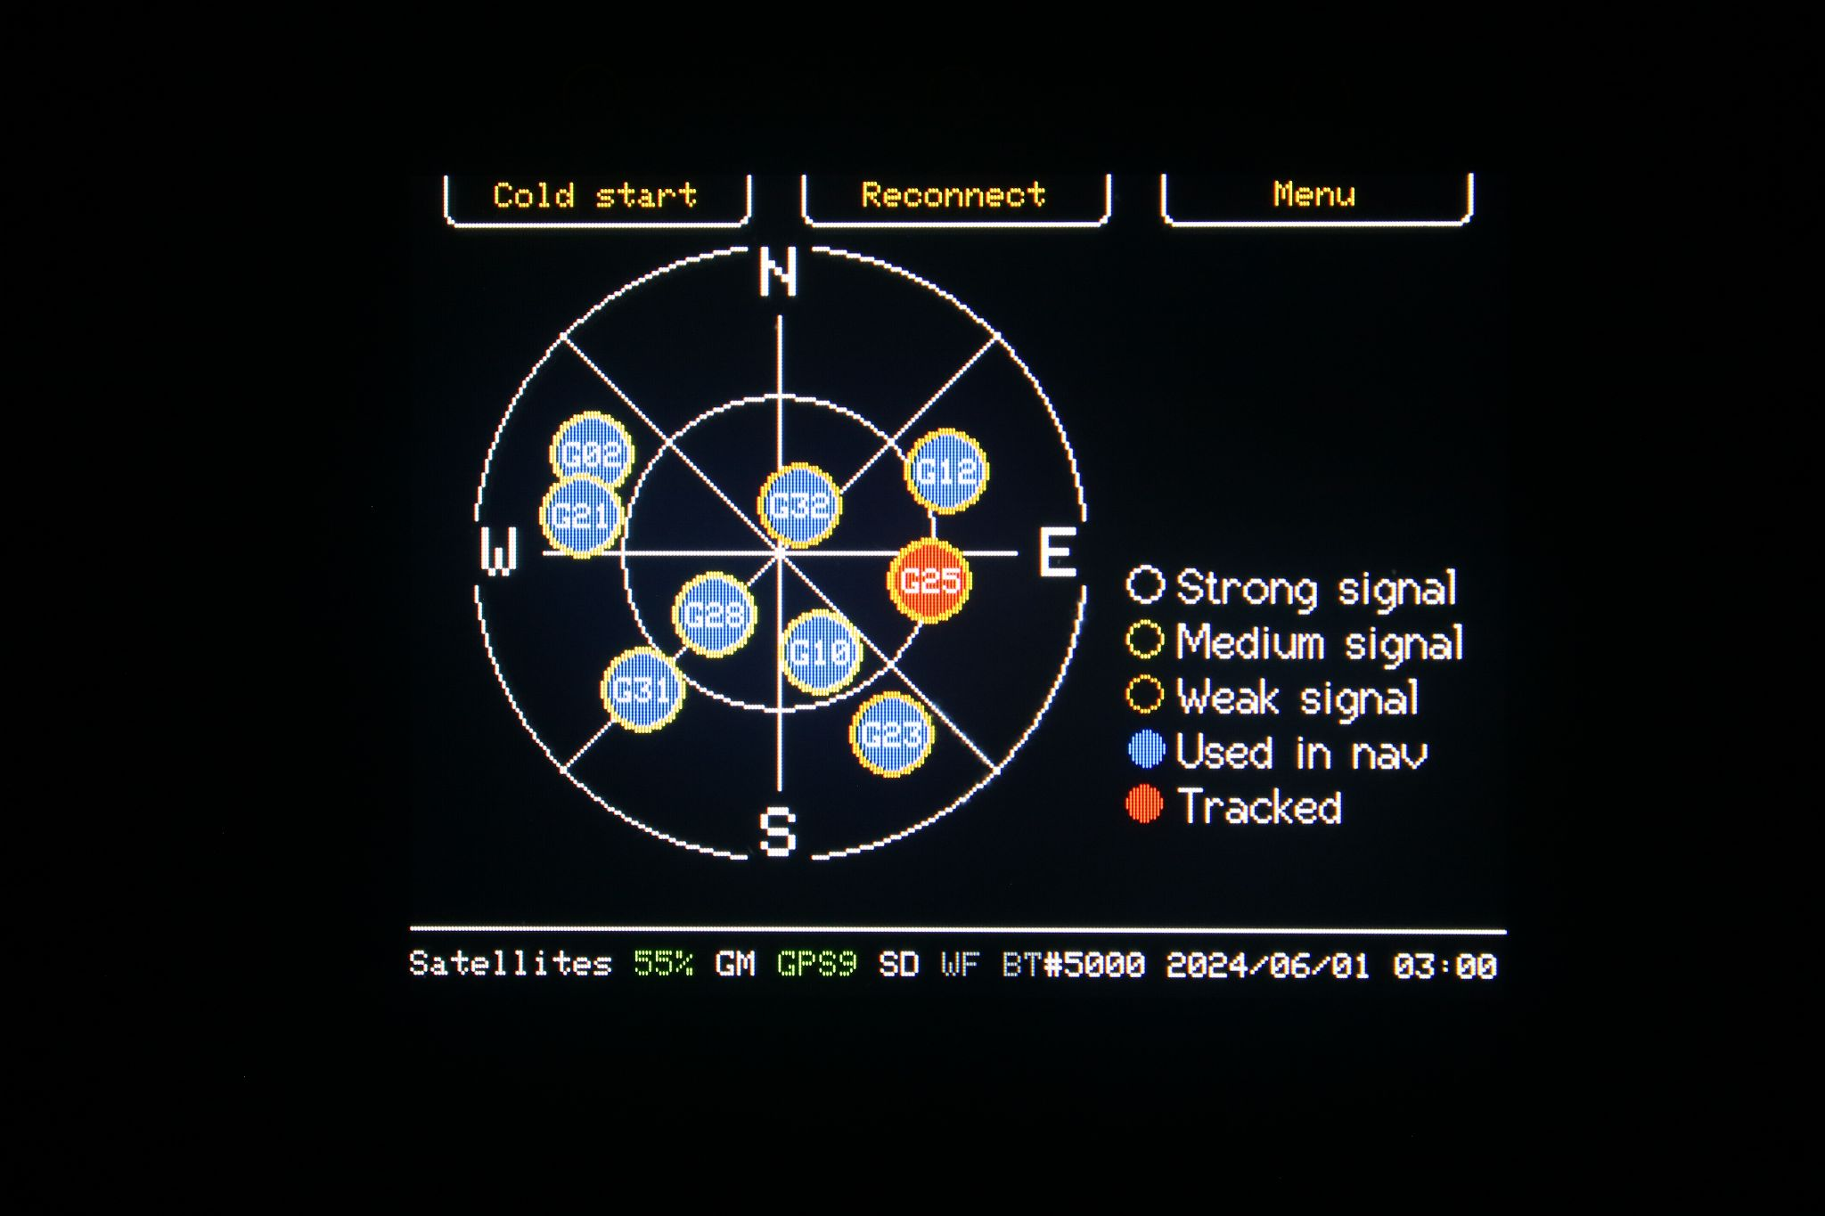
In this screen capture, the receiver is tracking nine satellites, all from the GPS constellation (prefix ‘G’), and using eight of them for its fix. All satellites show a medium signal strength.

Each satellite is represented by a colour-coded circle on a compass display.
- Filled colour = status:
  - Blue – Used in the most recent navigation fix;
  - Red – Tracked but not used in the navigation fix.
- Border colour = received signal strength:
  - White – Strong
  - Yellow – Medium
  - Orange – Weak
- Letter–Number code (for example, G12)
  - Letter indicates constellation (refer to table in section 6.1)
  - Satellite number within that constellation.

6.3 - Receiver operations
The left and middle buttons at the top of the Satellites screen provide configuration and troubleshooting operations for the receiver.
- Left button “Options”: Access a set of sub-menus to configure the receiver to use specific combinations of GNSS to improve accuracy based on the current regions or “Cold Start” the receiver.
- Middle button “Reconnect”: Occasionally, the receiver and controller cannot communicate over the serial link between them due to a mismatch of bit transfer rates. The Reconnect operation restores the synchronisation.

Note: In earlier firmware versions, the left button had only one function, Cold Start. Upgrade the firmware to use the options.

6.3.1 - Satellite options
The Satellites sub-menus configure the combinations of GNSS in use and provide a reset for the receiver.
- Satellites: Display the satellite “constellation” visible at the moment. View this screen to return to the main menu.
- Set default: Reset the receiver to its factory default GNSS combination (not available yet).
  - Set Americas: Optimise the GNSS combination for the Americas region (not available yet).
    - Set Europe/Africa: Optimise the GNSS combination for the Europe/Africa region (not available yet).
    - Set Asia/Oceania: Optimise the GNSS combination for the Asia/Oceania region (not available yet).
- Cold start: The receiver is reset and forced to reload its cached satellite information. Receiving fresh information can take several minutes but is usually faster if satellite-based augmentation is available. Cold start does not change the combination of GNSS constellations in use.
- Factory reset (not available yet): The receiver is reset to its factory default configuration.

6.4 - Dilution of precision (DOP)
The dilution of precision number displayed on the Drive and Survey mode screen, and recorded in log files gives an indication of the precision of the position fix. Lower numbers mean a more accurate and precise location.
Your bGeigieZen retrieves, displays and logs the Position Dilution of Precision (PDOP) from the GNSS receiver. It logs data points only when the PDOP is less than or equal to a programmed threshold (dop_max, default 5.00). The threshold is set on the web configuration server (see 4 - Configuration Web Server), and is shown read-only on the device under Settings > Utilities > About this device.
Documentation by u-blox AG, the manufacturer of the modules used in bGeigieZen:
A description of the purely geometrical contribution to the uncertainty in a position fix. Standard terms for the GPS application are:
GDOP: Geometric ( 3 position coordinates plus clock offset in the solution)
PDOP: Position (3 coordinates)
HDOP: Horizontal (2 horizontal coordinates)
VDOP: Vertical (height only)
TDOP: Time (clock offset only)
RDOP: Relative (normalized to 60 seconds and based on a change in geometry)
DOP is a function expressing the mathematical quality of solutions based on the geometry of the satellites. Position dilution of precision (PDOP), the most common such value, has a best case value of 1, higher numbers being worse. A low number of DOP (2) is good, a high number (>7) is considered to be bad. The best PDOP would occur with one satellite directly overhead and three others evenly spaced about the horizon. PDOP could theoretically be infinite, if all the satellites were in the same plane.
PDOP has a multiplicative effect on the user range error (URE) value. A URE of 32 meters with a PDOP of one would give a user an assumed best accuracy of 32 meters. A PDOP of 2 would result in an assumed accuracy of 64 meters. Many receivers can be programmed to stop providing position solutions above a specific PDOP level (6 is common).
Source: The GPS Dictionary: Acronyms, Abbreviations and Glossary related to GPS, ©2010 u-blox AG, Switzerland

Appendix A - Log and Journal files

A-1 Log files
The logs of geocoded measurements are stored as plain text files on the microSD card in a folder named drives.
Each file is named according to the start of the drive by year, month, day, hour and minute. For example, 2024-06-18_2307.log was started June 18, 2024, at 23:07 UTC.
The log format is the same as for the bGeigieNano, with minor differences.

At the top of the file, the header gives the format and options.
# NEW LOG
# format=3.1.1-zen/drives
# deadtime=off

Each measurement produces a record in the file. For example:
$BNRDD,5004,2024-04-16T13:47:43Z,34,4,694,A,4413.0426,N,7824.7346,W,196.8,A,8,183*66

- $BNRDD – standard device header
- 5004 – Device ID as a decimal integer
- 2024-04-16T13:47:43Z – Date-time as YYYY-MM-DDTHH:MM:SSZ UTC time (ISO-8601 format)
- 34 – CPM counts per minute as a decimal integer
- 4 – CP5s counts per 5 seconds as a decimal integer
- 694 – Total counted pulses since startup
- A – CPM validity flag - “A”: Available, “V”: Void
- 4413.0426 – Latitude as DDMM.mmmm, where DDMM is two digits of degrees and two digits of decimal minutes and mmmm is the decimal fraction of minutes. Values are always positive and the North-South is indicated in the next field. See note 1 for the exact calculation.
- N – N-S Latitude North-South
- 7824.7346 – Longitude as DDDMM.mmmm, where DDDMM is three digits of degrees and two digits of decimal minutes and mmmm is the decimal fraction of minutes. Values are always positive and the East-West is indicated in the next field. See note 1 for the exact calculation.
- W – E-W Longitude East-West of the prime meridian
- 196.8 – Altitude above mean sea level (MSL) in metres with decimal digits
- A – GPS fix indicator - “A”: Available, “V”: Void
- 8 – Number of satellites used in calculating the latest position fix.
- 183 – Dilution of precision (DOP) See Note 2 below. DOP is described in 6.4 - Dilution of precision (DOP).
- *66 – Record checksum, computed as the exclusive-OR of the bytes preceding the *.

Note 1: Given decimal degrees to 6 digits as DEG=DD.dddddd, calculate degrees and decimal minutes as DM=DDMM.mmmm. Longitude can have three digits of degrees (0-179).
Degrees = gather the integer portion of DEG and truncate the decimal degrees.
Minutes = (DEG − Degrees) × 60; to convert the remaining decimals to minutes.
DN = ( Degrees × 100 ) + Minutes + decimal point + the remaining four minute decimals
More precisely, in C++ code, starting with decimal_degrees as DD.dddddd:
double degrees = static_cast<int>(decimal_degrees);
double minutes = (decimal_degrees - degrees) * 60;
double degrees_minutes = (degrees) * 100 + minutes;
uint16_t log_degrees_minutes = static_cast<uint32_t>(degrees_minutes);
uint16_t log_fraction = static_cast<uint32_t>((degrees_minutes - log_degrees_minutes) * 1e4);
sprintf(buffer, "%04d.%04d", log_degrees_minutes, log_fraction);

Note 2: bGeigieZen records Position Dilution of Precision (PDOP) but Nano records Horizontal DOP (HDOP) due to different GNSS receivers. The differences are minor.

A-2 Journal files
(TO BE COMPLETED ??)

Appendix B - Using QGIS radiation toolbox

- Install QGIS from https://www.qgis.org/download/
- Install QuickMapServices plugin - more maps to choose from, no watermark. Both plugins are available from QGIS plugin installation tool (just enable "Experimental" plugins in settings)
- Get the QGIS radiation toolbox: https://plugins.qgis.org/plugins/radiation_toolbox_plugin/
- Or Install QGIS Radiation Toolbox Plugin from the plugin menu.

- Add a map layer
- Open radiation Plugin (click the radiation icon on the toolbar)
- On the left side menu select load and load the log file.
- See the documentation of the plugin and how to edit/delete the points. Documentation: https://opengeolabs.gitlab.io/radiation-toolbox/qgis-radiation-toolbox-plugin/

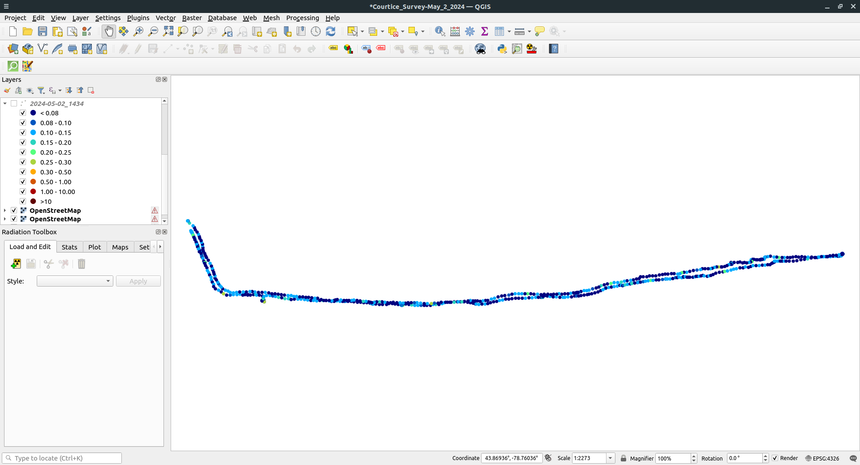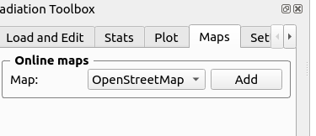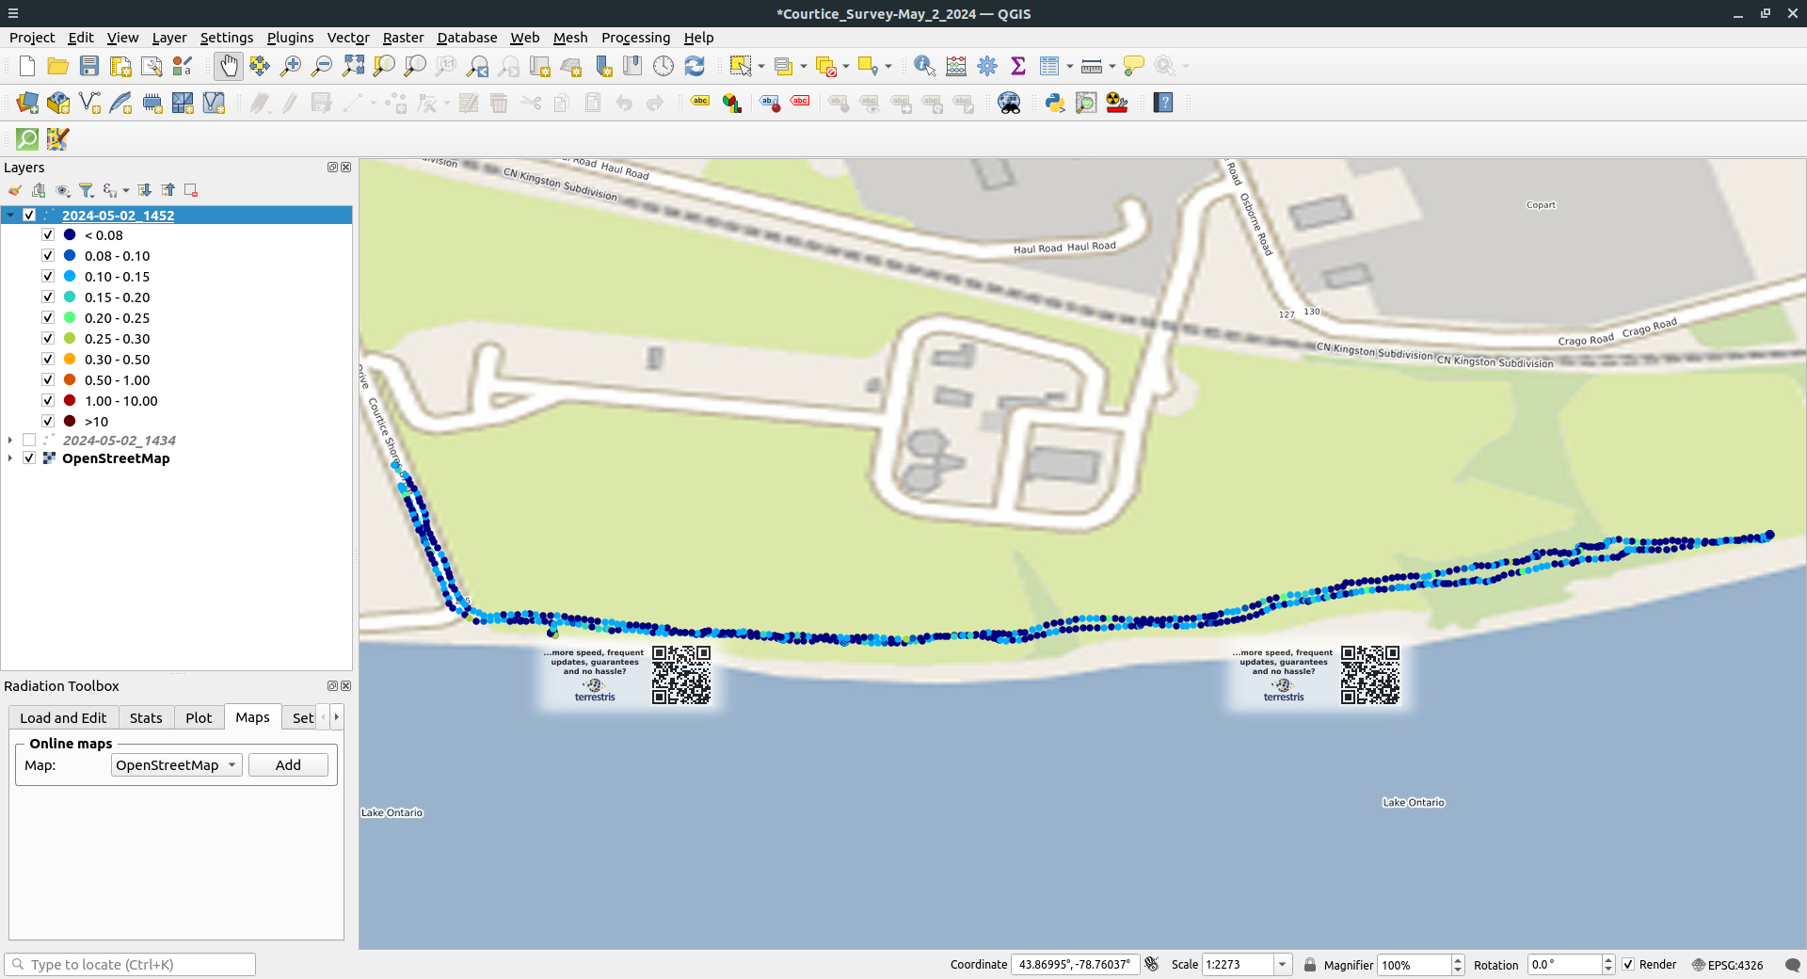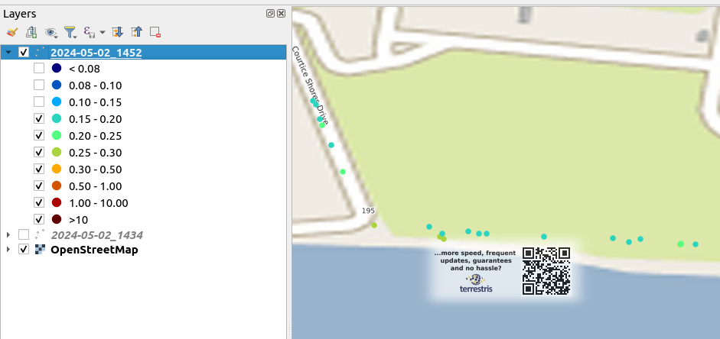

Appendix C Hardware pictures

bGeigieZen V3.0.3 schematic
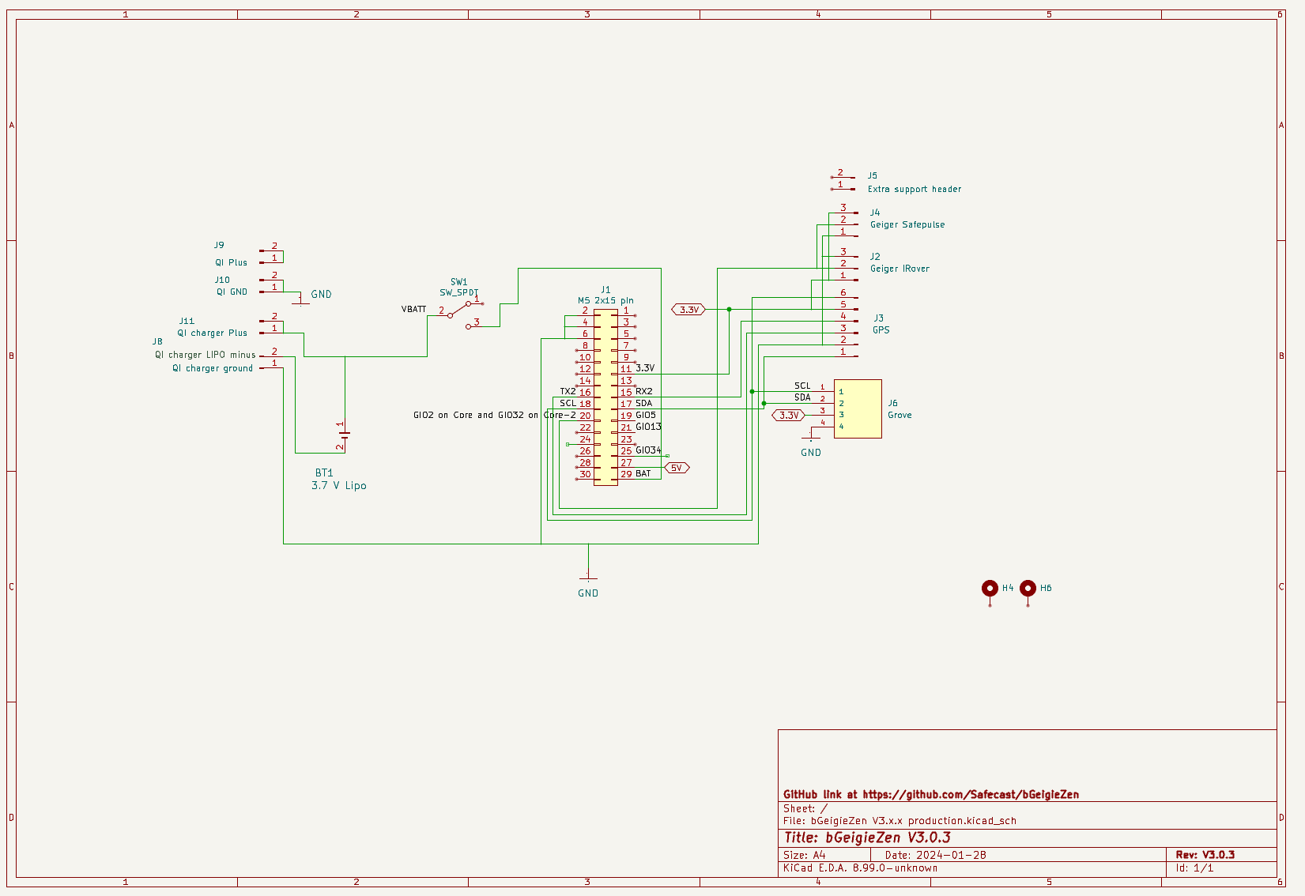dsdad

bGeigieZen V3.0.3 board

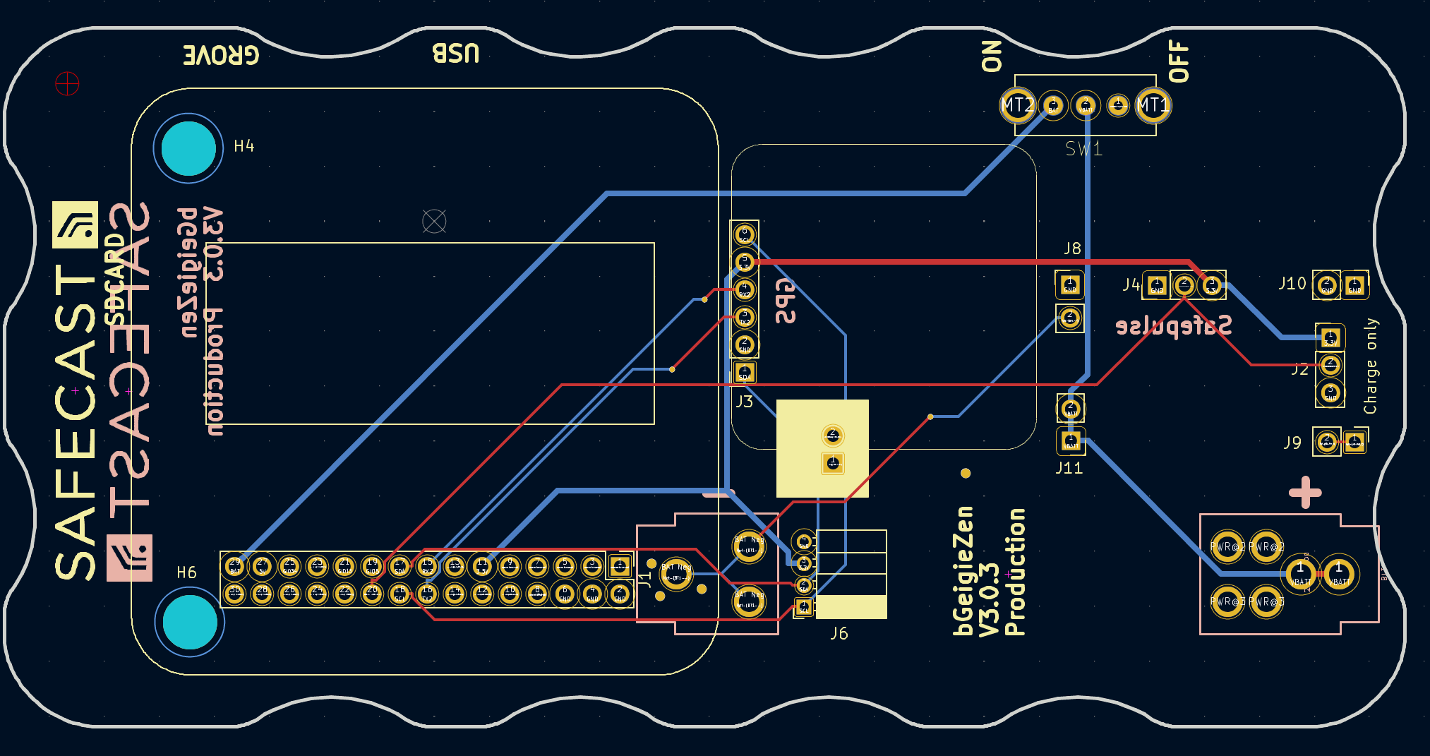

BGEIGIEZEN V.3.0.3
SYSTEM CONFIGURATION THROUGH THE microSD CARD
(Ed. 01)
Alberto Villa, 2024-08-12

INDEX
1. INTRODUCTION 2
2. FLOWCHART 2
3. DETAILED PROCEDURE 3
3.1 - Editing the <SAFEZEN.txt> file 3
3.2 - Loading the configuration data into the bGeigieZen 4
3.3 - Setting the bGeigieZen operating mode 8

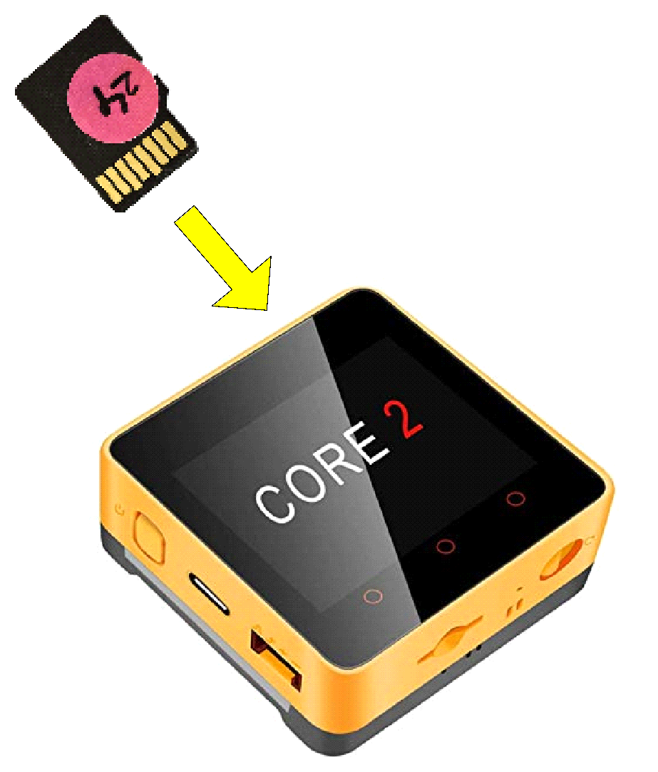

Appendix D(SDcard)

1. INTRODUCTION SDcard
The following configuration procedure through the microSD card takes place after having “burned” the bGeigieZen firmware into the M5StackCore.
The description is based on a bGeigieZen board V3.0.3 with a Core2-AWS module, using the received memory card containing the <SAFEZEN.txt> file with the basic (default) configuration items. An initial flowchart summarizing the main steps is followed by a detailed description.

2. FLOWCHART
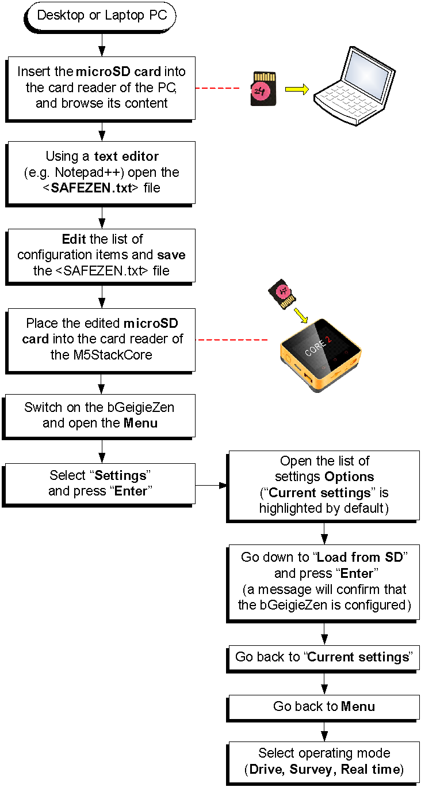

3. DETAILED PROCEDURE
Three main phases are required to configure the bGeigieZen through its microSD card:
- Edit with a desktop or laptop PC the <SAFEZEN.txt> file found into microSD card.
- Insert the microSD card into the M5StackCore module and load the new configuration data into its non-volatile memory.
- Define the operating mode of the bGeigieZen (Drive, Survey or Real time).

3.1 - Editing the <SAFEZEN.txt> file
STEP 1:
Insert the microSD card into a reader and browse its content. Open the file <SAFEZEN.txt> with a suitable text editor like for instance:
- Notepad++
- Windows’ Notepad
- Textedit in MacOS (keeping the file as a “plain text” document).
The very first time, you will see the list of default parameters, beginning with the very important device ID number (not to be changed!). For instance:
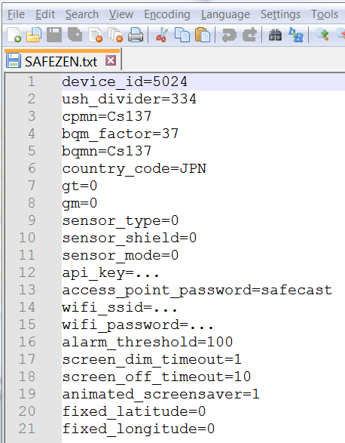
STEP 2:
Edit/complete the list with your personal parameters (e.g.: country code, API key, WiFi network name (SSID), WiFi password, fixed latitude, fixed longitude, fixed range, etc.).
NOTE:
- Do NOT change the default access point password “safecast”.
- Refer to the User Manual for more details about all the available parameters.

STEP 3:
Save the edited <SAFEZEN.txt> file.

3.2 - Loading the configuration data into the bGeigieZen
STEP 1:
Insert the updated microSD card into the cardholder of the M5StackCore (contacts facing UP!):
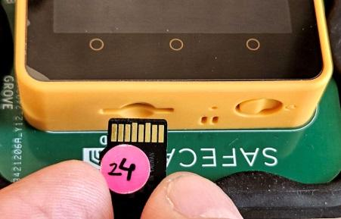
STEP 2:
Switch ON the bGeigieZen. The display shows an opening page (soft keys inactive) followed by the (default) “Drive Mode” screen. Here only the two lateral soft buttons are active, assigned as “Stop driving” and “Menu”:
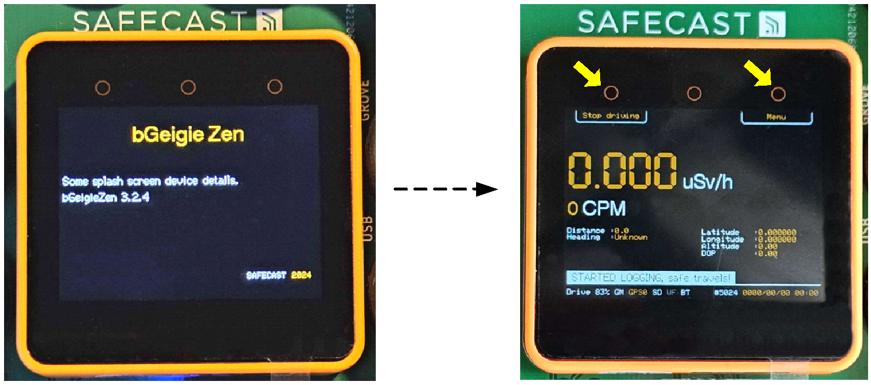
NOTE: By default, the screen "dim" timeout is 60 seconds and the screen "off" (total blanking) timeout is disabled (0), parameters that can be changed by the user.
If the screen goes off too early during this procedure, it can be immediately reactivated (for the next 10 seconds) just by tapping on the touch-screen.
STEP 3:
Press the “Menu” soft key (top right button) to open the menu list. Now the functions of the three soft keys are, from left to right: “Down”, “Up” and “Enter”. The first selected item is “Drive mode”.
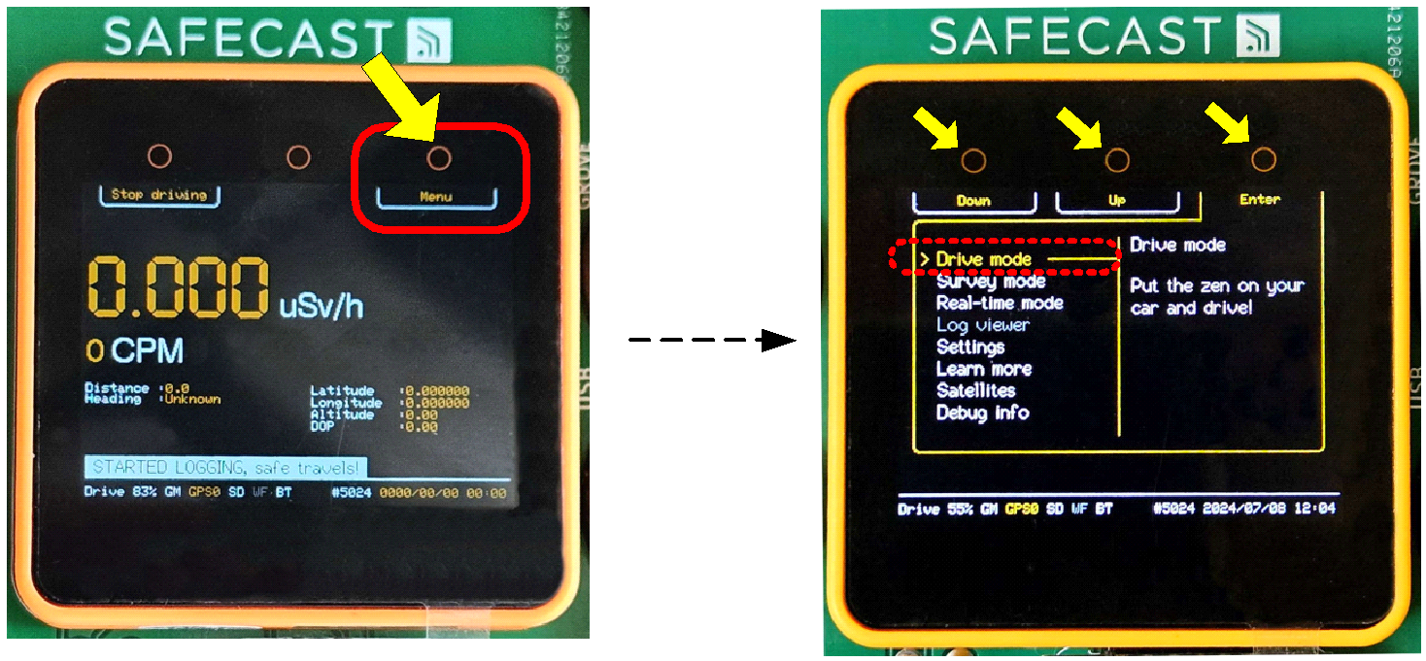

STEP 4:
Press the “Down” soft key (top left button) to scroll the highlighted items until “Settings” is reached:
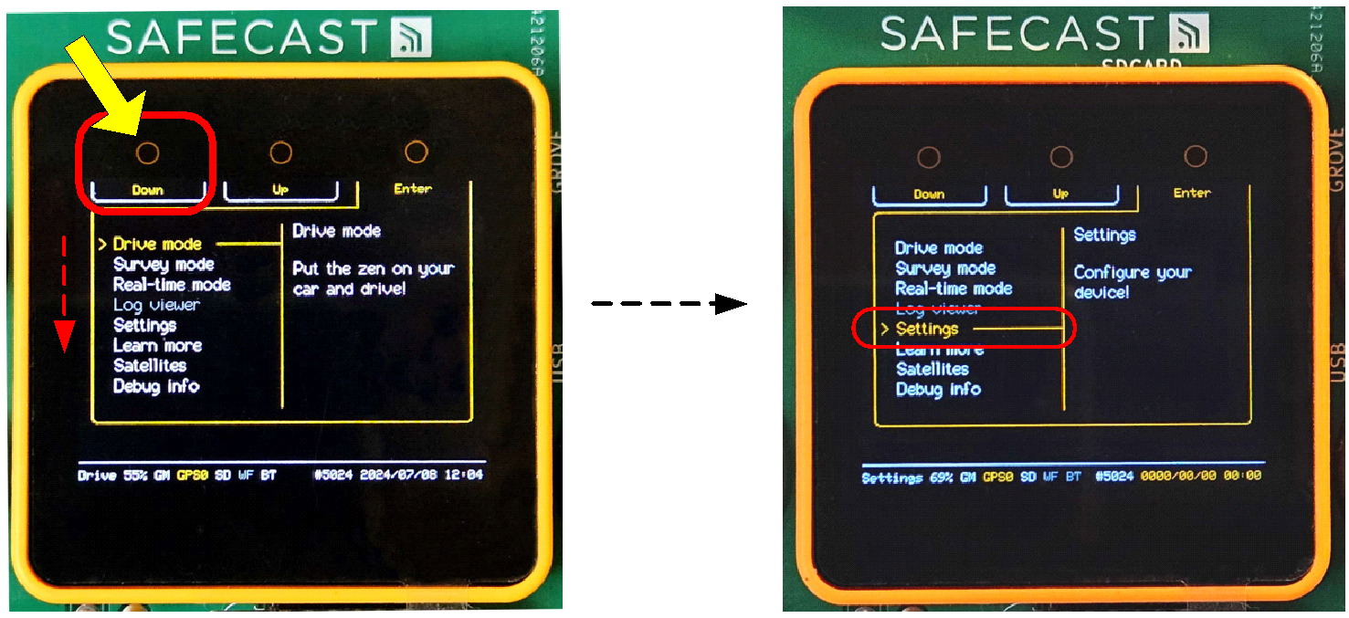
STEP 4:
Press the "Enter" soft key (top right button) to open the Settings menu. Now, from left to right, the functions of the three soft keys are: "Down", "Up" and "Enter", and the first selected (highlighted) item is "Display".
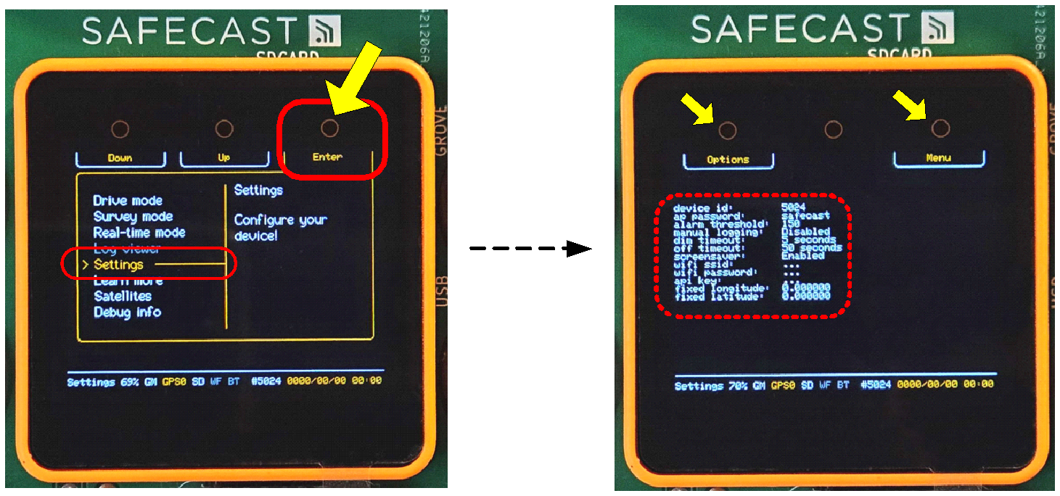
STEP 5:
Press the "Down" soft key (top left button) to scroll the highlighted items until "SD card" is reached, then press the "Enter" soft key (top right) to open the SD card submenu, listing "Load from SD", "Save to SD" and "Wipe SD card". The first item, "Load from SD", is already highlighted:
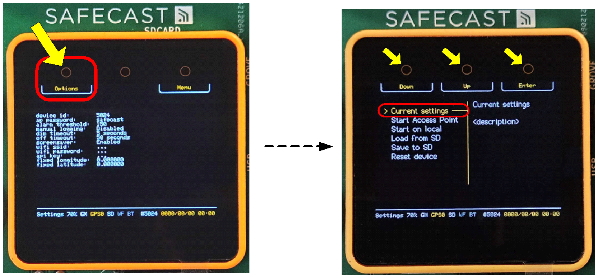
STEP 6:
The "Load from SD" item is highlighted.
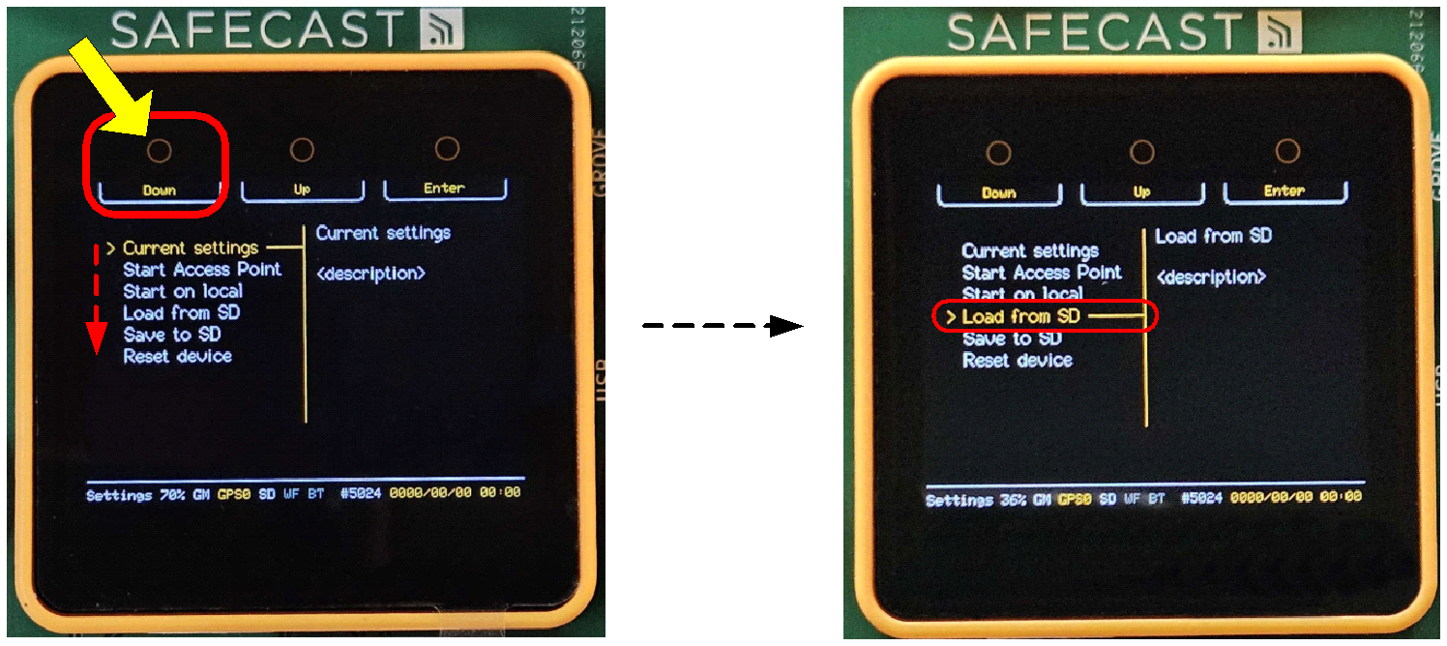
STEP 7:
Press the “Enter” soft key (top right button) to start loading the data into the non-volatile memory of the M5StackCore. At the end a message appears for a short while confirming that the operation has been successfully concluded (“SD CONFIG LOADED, settings have been updated”):
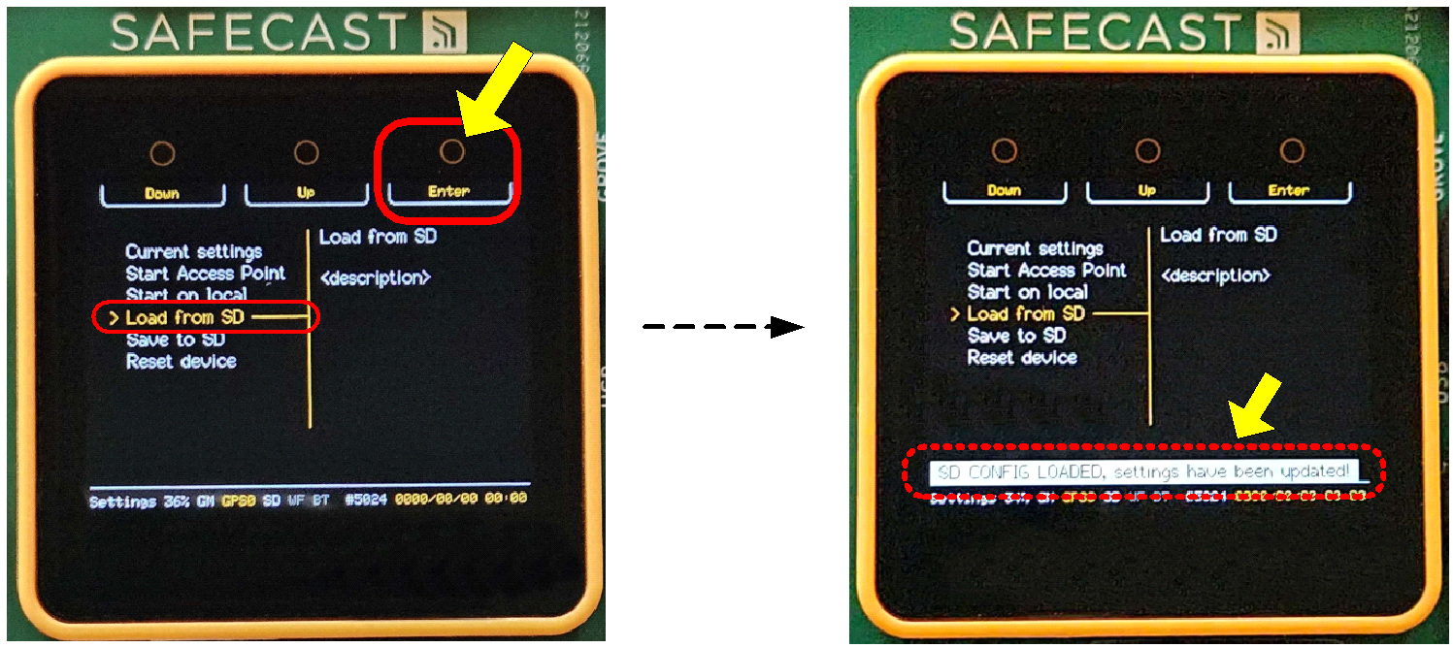
STEP 8:
Press the "Menu" soft key (top right) to return to the SD card submenu, then press "Back" twice to return to the Settings menu.
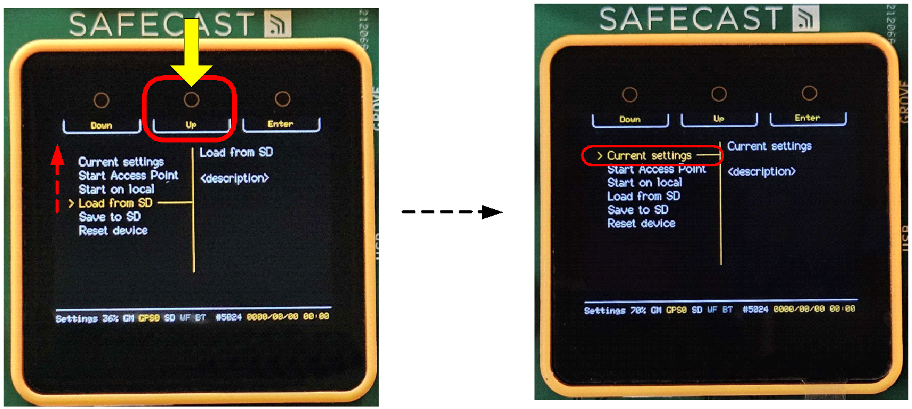
STEP 9:
Navigate to "Utilities" and press Enter, then navigate to "About this device" and press Enter to visualize the updated parameters (Device settings, Location settings, Connection settings).
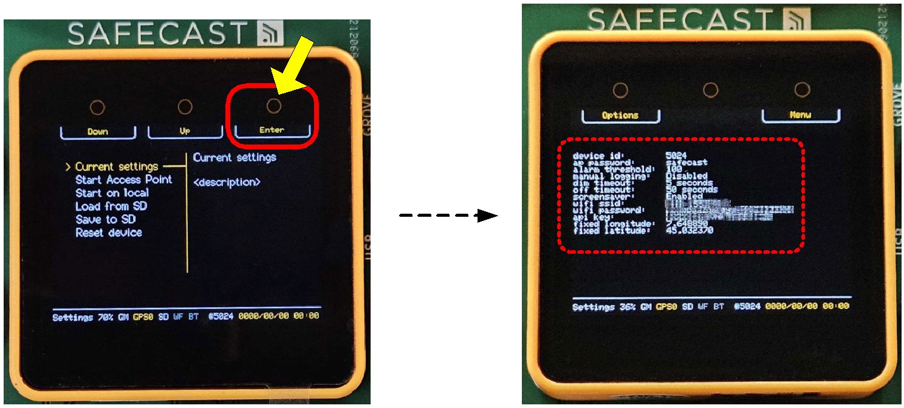

STEP 10:
Press the "Back"/"Menu" soft key repeatedly to return to the main menu.
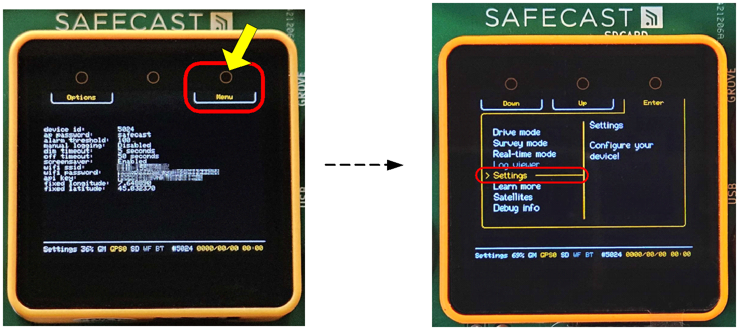

3.3 - Setting the bGeigieZen operating mode
Press the “Up” soft key (top center) to scroll upwards the highlighted items until the desired operating mode is reached (Drive, Survey or Real time), then press the “Enter” soft key (top right):

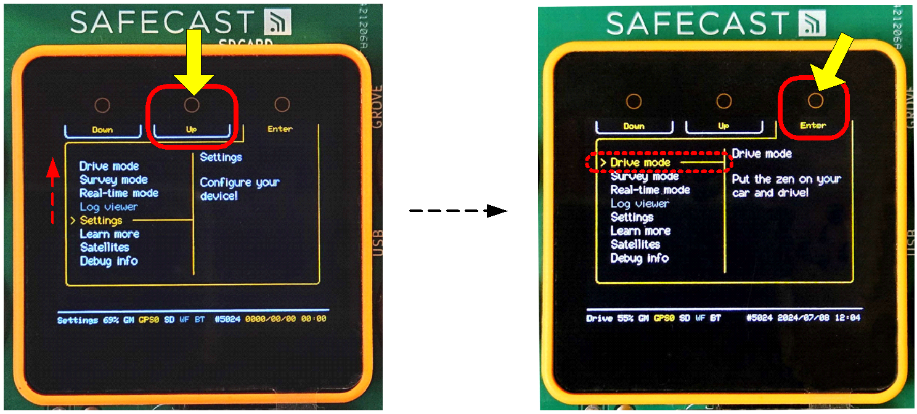

Appendix E (battery changing)

BGEIGIEZEN V.3.0.3
CHARGING THE 3.7 V LiPo CELL
(Ed. 01)
Alberto Villa, 2024-08-14

INDEX
1. INTRODUCTION 2
2. FLOWCHART 2
3. DETAILED PROCEDURE 2
4. CHARGER CIRCUIT AND BATTERY TEST 5

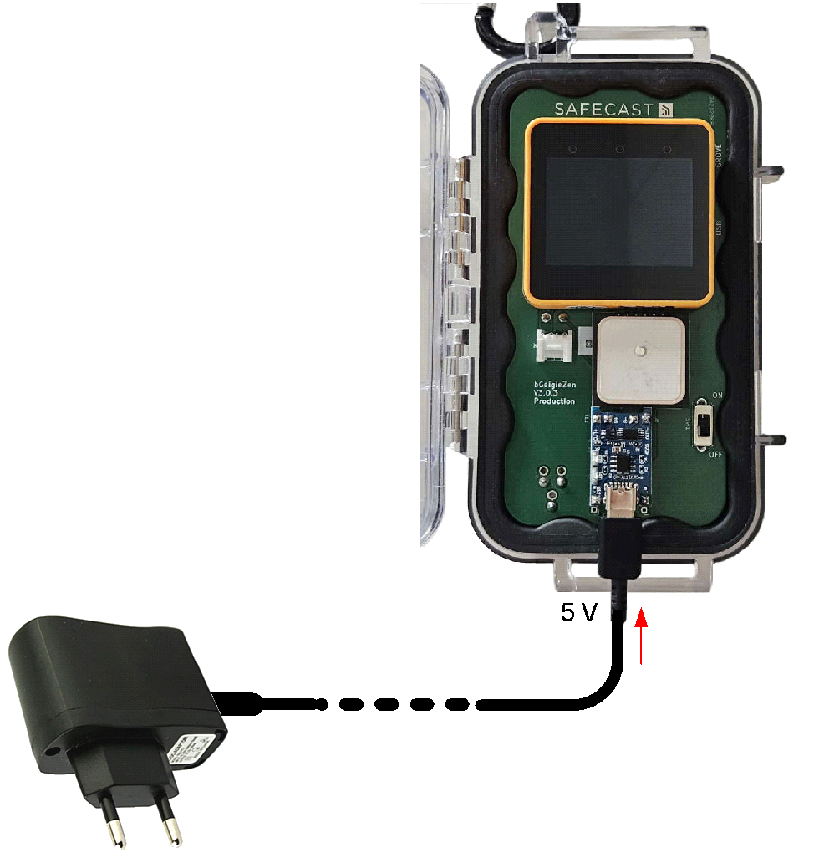

1. INTRODUCTION
This description of the LiPo cell charging procedure is based on a bGeigieZen board V3.0.3 with a Core2-AWS module.

2. FLOWCHART
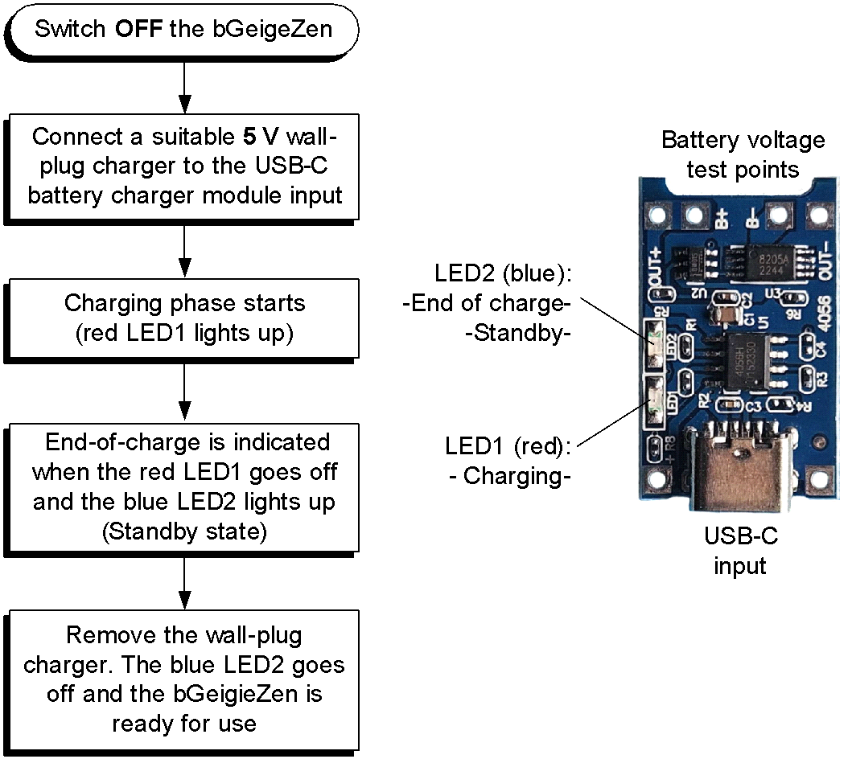

3. DETAILED PROCEDURE
NOTES:
- Use a 5 V wall-plug charger rated for at least 5 W (5V/1A).

- A tested 25 W USB Super-Fast EP-TA800 wall charger (Samsung) did not send any current to the bGeigieZen. Probably there is a problem with the power delivery negotiation method with these kind of super fast chargers.

- The LiPo cell charger module of the bGeigieZen is based on a TP4056A chip providing a regulation voltage of 4.20 V. The circuit is configured for a typical “Constant Current” value of 1 A, a value that may range between 0.95 and 1.05 A.

- The thermal power dissipated by the TP4056A chip is mainly given by the product of the charge current (1 A) by the difference between the input voltage (5 V) and the LiPo cell voltage. Hence, during the “Constant Current” charging phase some heating of the device is to be expected, especially if the LiPo cell is at its lowest possible voltage.
STEP 1:
- Switch OFF the bGeigieZen to dedicate all the available charging current to the LiPO cell. If kept powered, the M5stackCore drains away approx. 0.2 A from the charge current, increasing the charge completion time.

- Connect the wall-plug charger to the USB-C port of the bGeigieZen’s LiPo cell charger module.
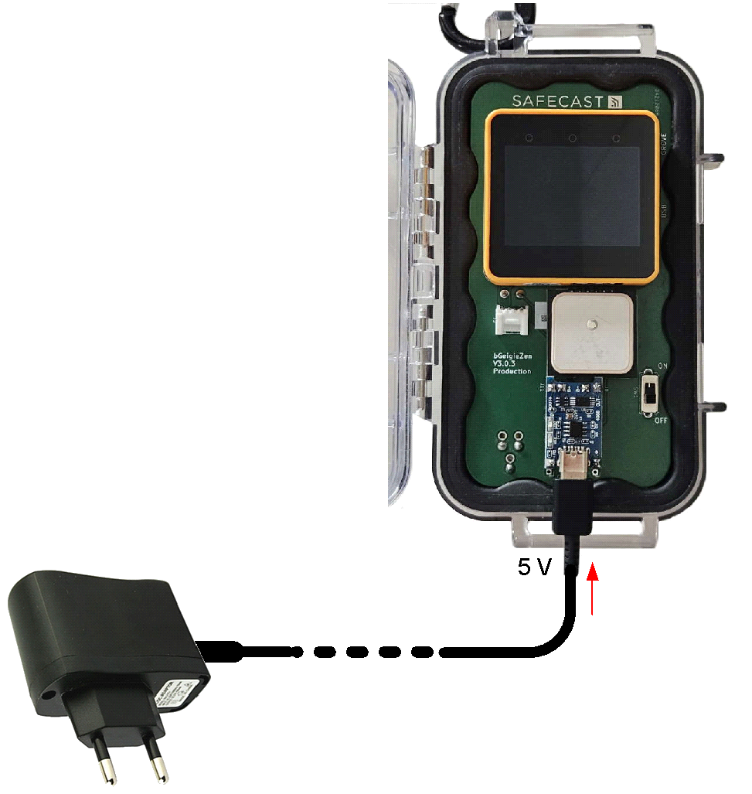
STEP 2:
Connect the wall-plug charger into the AC mains socket. The charging phase begins, as indicated by the status red LED1:
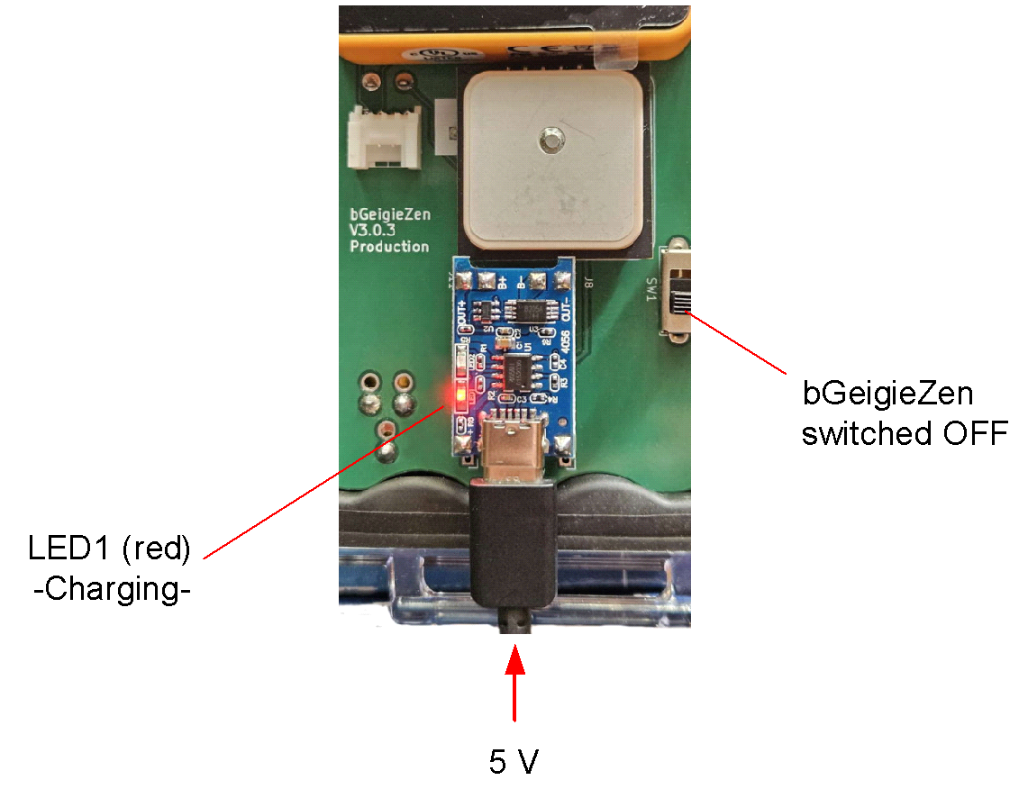
STEP 3:
When the LiPo cell is fully charged the red LED1 goes off and the blue LED2 lights up, indicating that the cycle is terminated and the charger device is now in the “Standby” mode (LiPO cell voltage kept at 4.2 V):

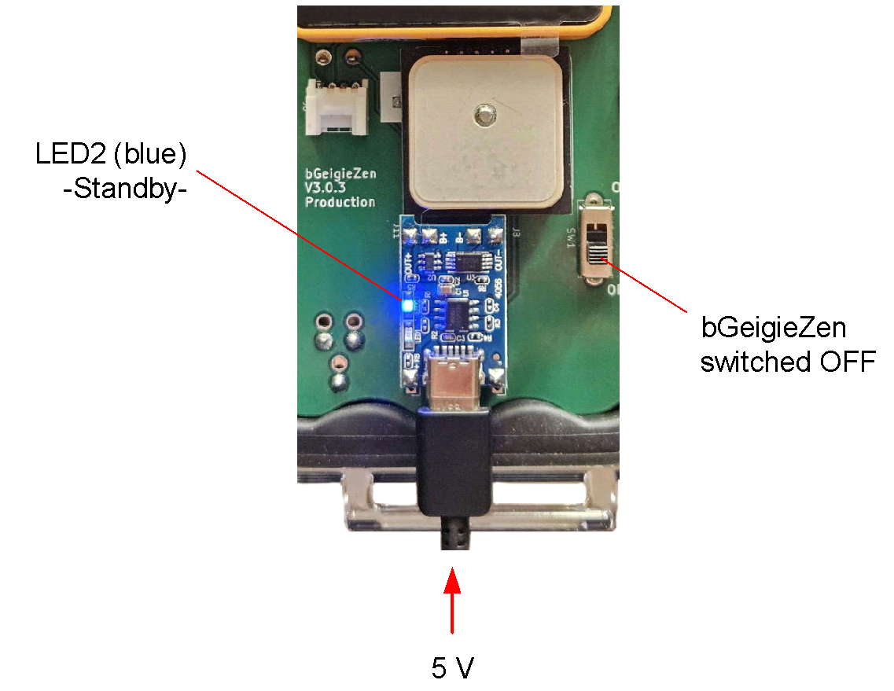
NOTE: If in these conditions the bGeigieZen is powered ON with the wall-plug charger still connected, the battery level indicator in the bottom line of the display will show a value around 97÷98%.

STEP 4:
Disconnect the wall-plug charger. The bGeigieZen is now ready to operate.
NOTE: The sum of the internal resistance of the LiPo cell with the resistance of the solid-state protection switch will cause a small voltage drop when the bGeigieZen is powered ON and the wall-plug charger is disconnected.
Therefore in this case the charge level indicator in the bottom line of the display will show a value around 93%, even if the battery has been just fully charged.

4. CHARGER CIRCUIT AND BATTERY TEST
The LiPo cell charger module of the bGeigieZen contains a TP4056A chip completed with a battery protection circuit (DW01A) and a dual MOSFET switch (FS8205) arranged as shown in this block diagram:
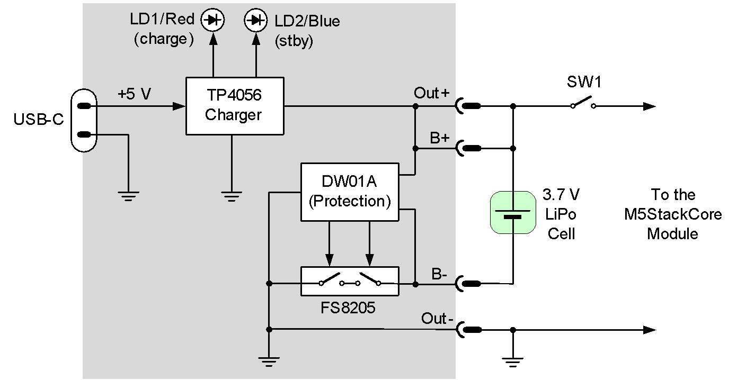
The physical layout of the module is indicated in the following figure:
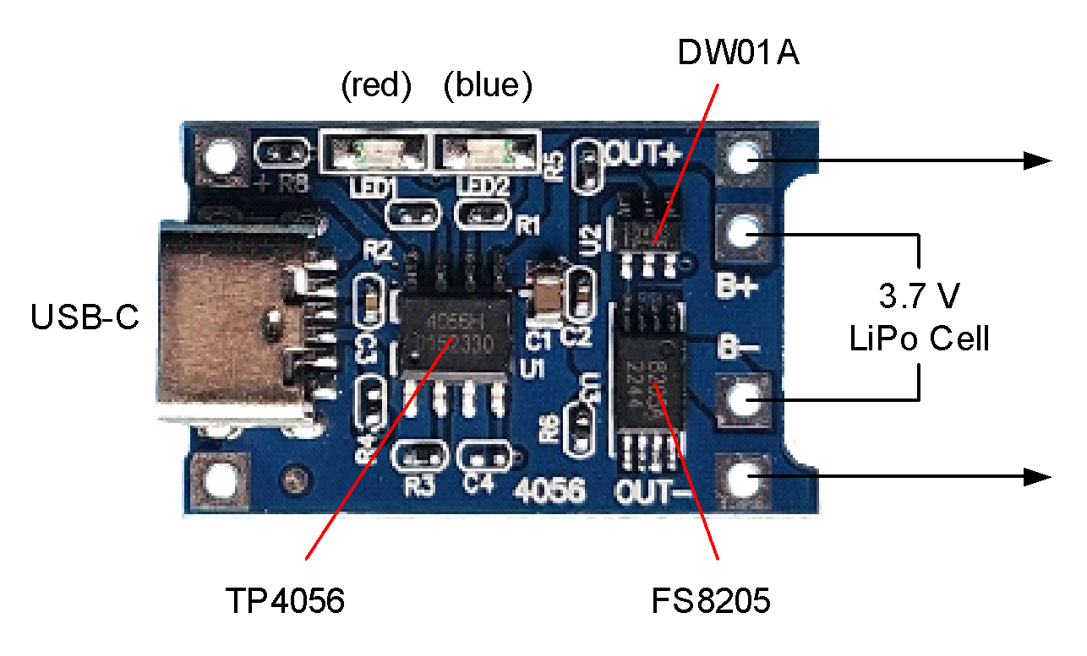
Note that the protection switch placed in series with the negative pole of the LiPo cell adds its “ON” resistance (typically around 20÷25 mOhms) to the internal resistance of the battery, and both contribute to a small drop of the available voltage during the normal operation of the bGeigieZen. Therefore, If you check the battery voltage with a digital multimeter you will find slightly different results according to the following conditions:
- If the bGeigieZen is switched OFF, the voltage can be measured indifferently between pin Out+ (or B+) and pin Out-, or between pin Out+ (or B+) and pin B-. No series resistance drop occurs, and you will get the highest values.

- If the bGeigieZen is ON, the current drain will cause slight voltage drops. The value measured between pins Out+ (or B+) and Out- will be a few mV lower (typically 4 to 5 mV) than the one measured directly across the LiPo cell, between pins Out+ (or B+) and B-.

Software install/M5Burner
BGEIGIEZEN V.3.0.3
SOFTWARE INSTALLATION
(Ed. 01)
Alberto Villa, 2024-08-09

INDEX
1. INTRODUCTION 2
2. FLOWCHART 2
3. DETAILED PROCEDURE 3
3.1 – Installing the USB VCP Driver 3
3.2 - Installing the Uniflow Firmware Burning Tool 3
3.3 - Installing (“burning”) the firmware 5

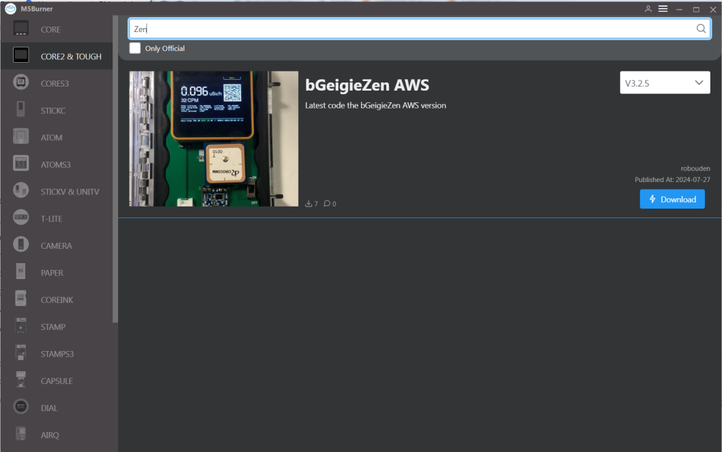

1. INTRODUCTION
The procedure described here is based on a bGeigieZen board V3.0.3 with a Core2-AWS module. An initial flowchart summarizes the main steps, followed by a step-by-step description.
NOTE:
The firmware “burning” has worked correctly only after the installation of the recommended USB driver using the file <CP210xVCPInstaller_x64_v6.7.0.0.exe> in an Acer Aspire 5 laptop running Win11. No success with an old desktop and Win7.

2. FLOWCHART
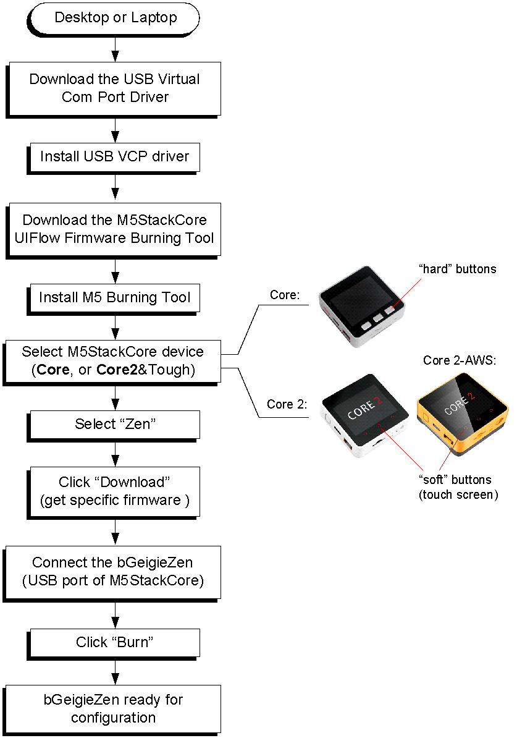

3. DETAILED PROCEDURE
The “burning” of the firmware into the M5StackCore of the bGeigieZen must be preceded by the installation of a suitable USB driver, followed by the M5 UIFlow Firmware Burning Tool.

3.1 – Installing the USB VCP Driver
Open the page https://docs.m5stack.com/en/uiflow/m5core2/program
Go to part 2, “USB Driver Installation” and download the compressed file with the USB Virtual Com Port Driver CP210x_VCP according to your current O.S.:
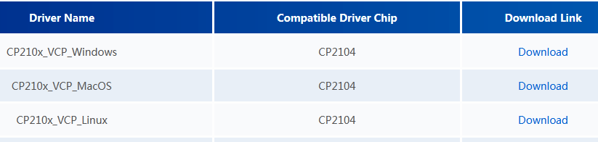
Decompress the file. In case of Windows 10/11, double click on the x64 version of the driver (CP210xVCPInstaller_x64_v6.7.0.0.exe).

3.2 - Installing the Uniflow Firmware Buring Tool
Open the page https://docs.m5stack.com/en/uiflow/uiflow_web . Go to part 2, “M5Burner Installation” and download the compressed file according to your current O.S.:
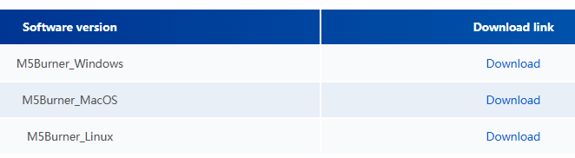
Decompress the zipped file. In case of Windows 10/11, double-click on the file <M5Burner.exe>. The M5Burner page appears, showing on the left a column for the selection of the device type, a search field on top, and on the right window a list of the available firmware and their versions:
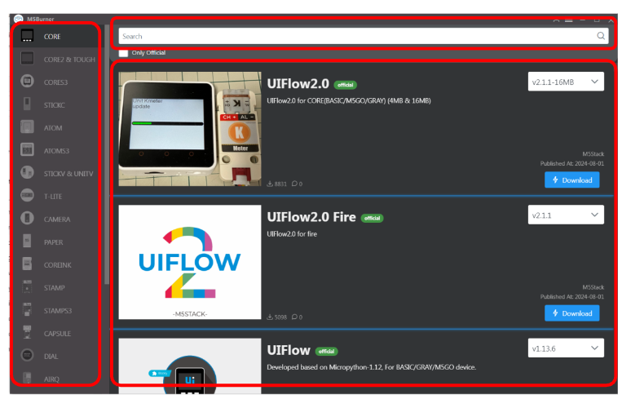

Select your M5StackCore type in the left column:
- If the M5StackCore has three top-side “hard” buttons, then choose “CORE”:
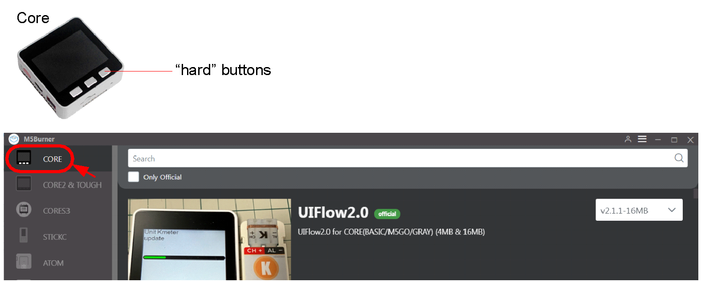

- If the M5StackCore has three top-side “soft” buttons, then select “CORE & TOUGH”:
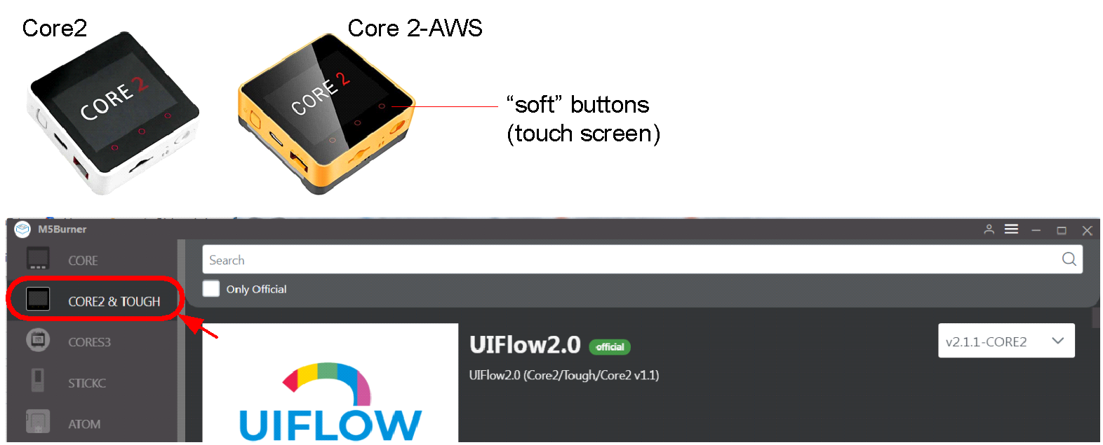

Type “Zen” (without brackets) into the search field. Immediately the page for downloading the firmware dedicated to the bGeigeZen (a Core2-AWS module in this example) appears:
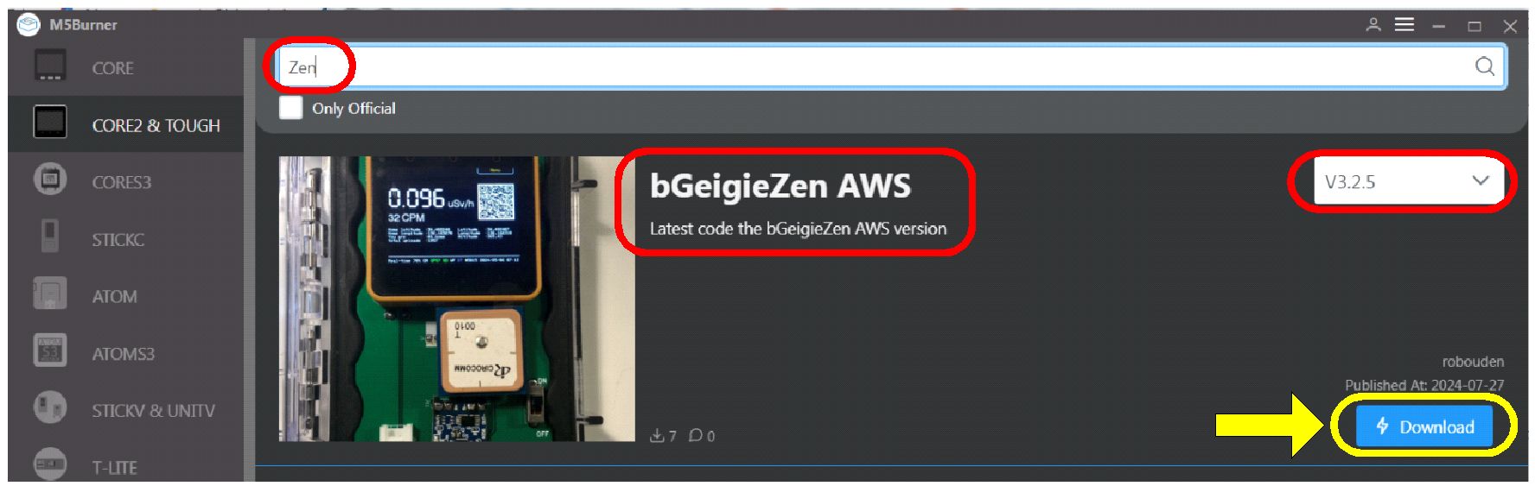
NOTE: The latest version of the firmware is shown in the top right field.Click the “Download” button. After a while a message confirms that the download has been successfully concluded:
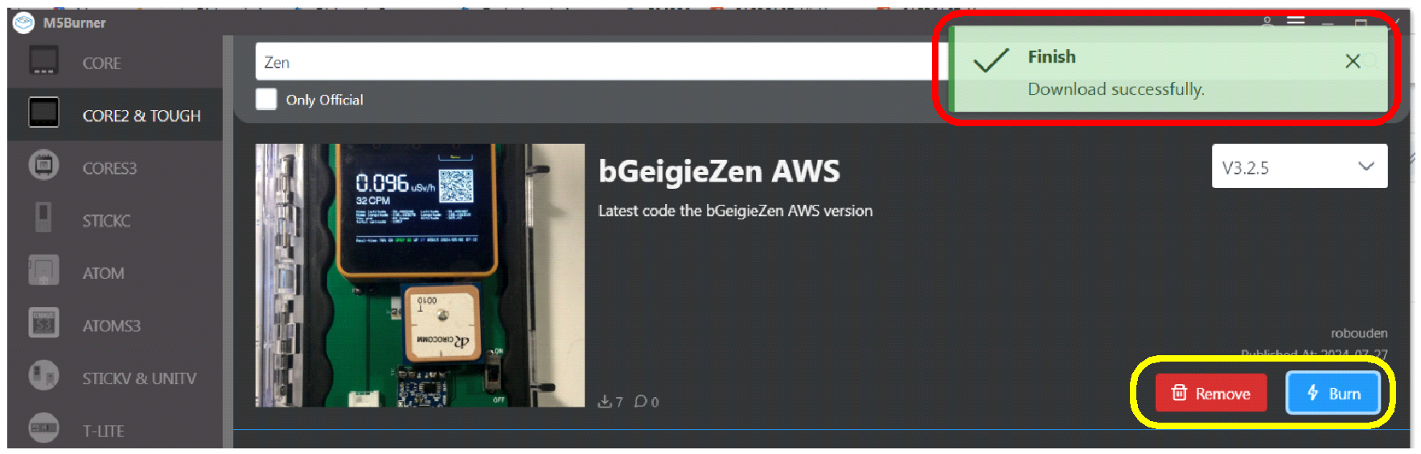
NOTE: Now the “Download” button is now replaced by a “Remove” and a “Burn” button.

3.3 - Installing (“burning”) the firmware
Connect the M5StackCore of the bGeigieZen with an USB-C cable (lateral connector). The M5 is now powered through the USB cable; the screen is uniformly white and flashes to black for a short instant at a periodical rate:
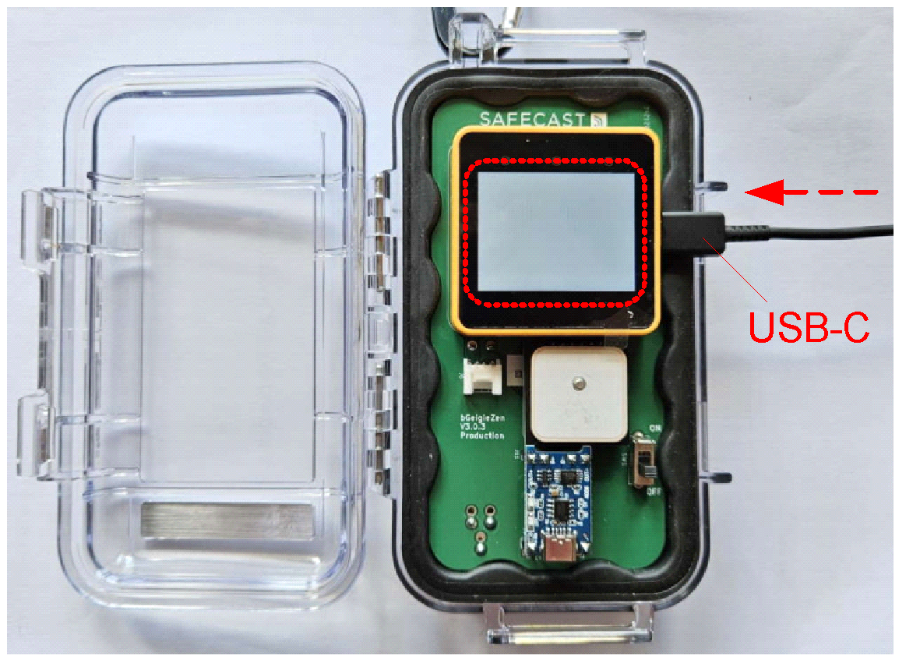
Note: If your USB-Port on the computer has not enough power output (happens often on the front ones) then the M5StackCore won´t be detected correctly by the software and the installation of the firmware will fail during burning.

Click on the “Burn” button:
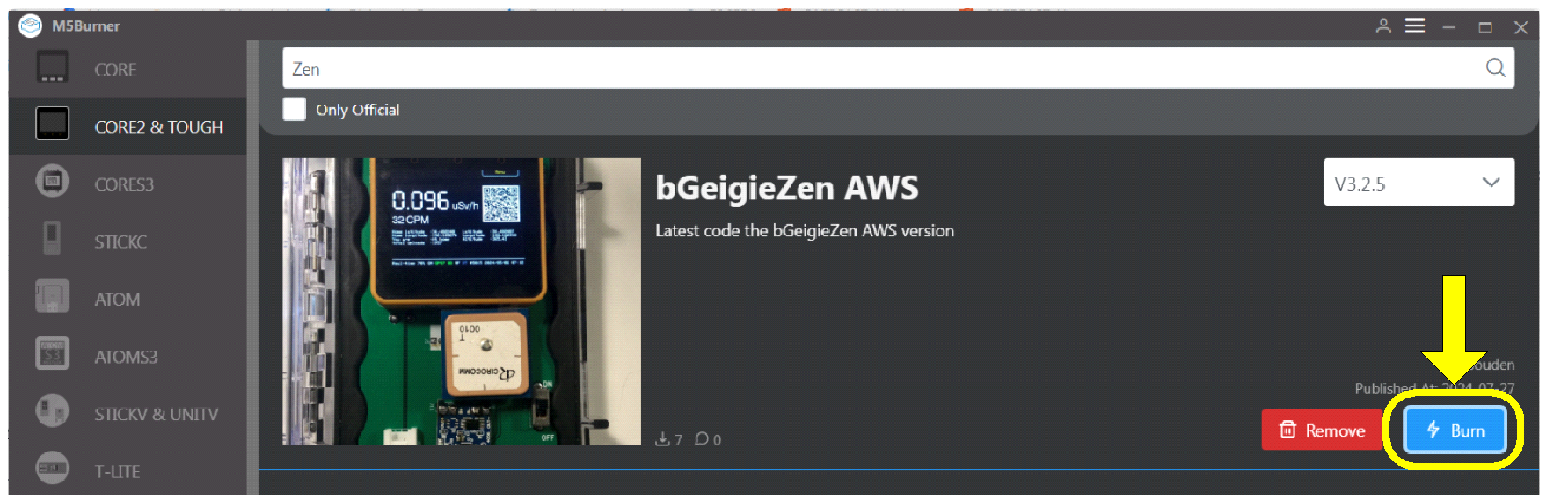

A window pops-up for setting the COM port and the data rate through drop-down lists. For instance:
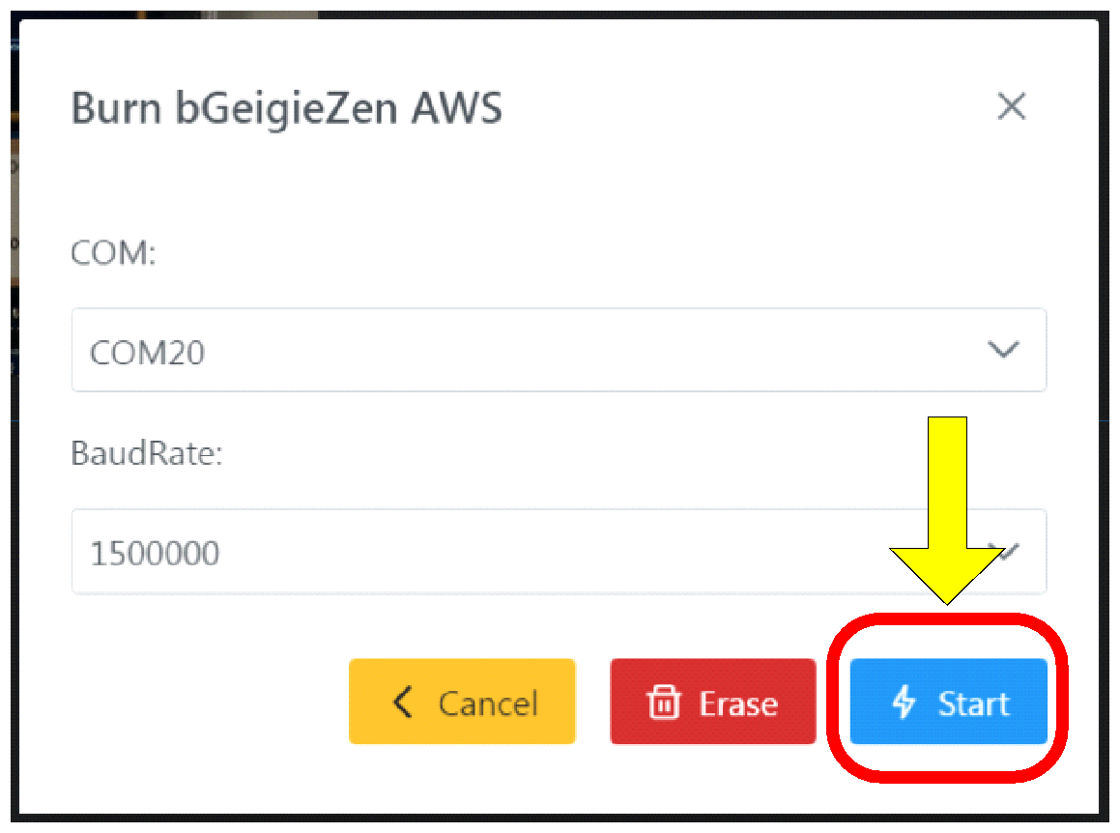
Click on the “Start” button; a message window appears showing the status of the burning procedure:
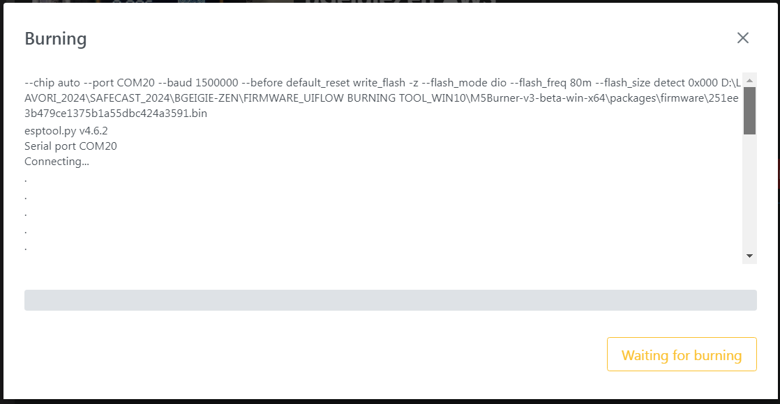

At the end, the bGeigieZen will be ready for the configuration of the operational parameters. These are set by:
- Editing the default <SAFEZEN.txt> file in the microSD memory card;
- Inserting the card into the card slot of the M5StackCore;
- Loading this file into the M5StackCore by using the “soft” keys of the touch-screen display.

Appendix F - Uploading Data to the Safecast Database

Uploading Data with the Safecast API
Your bGeigieZen is designed to submit data to the Safecast database through the Safecast API . The upload procedure is the same as for the bGeigieNano.
- You take the mini sd-card out of the bGeigieZen and
- Put the sd-card with a sdcard reader in a computer.
- Send the data (in the drive/journal folders) to the Safecast API.
To enable data submission, you’ll need to obtain an API key. The key is a credential that gives you access to the API, much like a username and password give you access to an email account.
You can register on the Safecast site to get an API key: https://api.safecast.org
You can learn about how the Safecast API works by visiting the API documentation: https://api.safecast.org
If you want to see your data directly on map, you can summit the data to https://simplemap.safecast.org (this requires also a username/email and an API key.

FAT32 is a Microsoft Windows file format that is widely supported by other operating systems and embedded microcontrollers because of its relative simplicity.
Notepad++ is a free open source editor for text and program files: https://notepad-plus-plus.org/

